1. **INTRODUCTION**
   1. **BACKGROUND OF THE STUDY**

Attrition is the term which refers the context where employee is leaving the organisation. The metric used to measure the Attrition is termed as Attrition Rate.

The metric attrition rate projects the attrition rate caused by both scenarios like voluntary resignation and company lay-off.

In the world best context employee would love to do their job with various perceptions like interest over the work/profession, co-workers ‘relationship, best superior guidance, means to earn the pay which satisfy the personal or family needs in order to leave the working company. But as every coin has two sides the real version of world is employees tend to leave the company while imputing various reasons like to earn more money (pay), hatred towards present company working conditions, dissatisfaction towards the superior etc. Which results in attrition rate.

Every company tend to follow its own strategies in order to over the attrition problem as well reduce the attrition rate. Few strategies are like:

* + Maintaining the Buffer in advanced (quite hard in real time) - until unless it is well reputed company.
  + Providing good working conditions.
  + Improve the working hours, Paying adequate pay (fair in nature).

As, such companies tend to opt for various way to reduce and overcome attrition. Attrition is one of the important issues that involve money of the organisation in many scenarios like pay, training cost, incentives etc. so, proper analysis of factors available to take decisions play a major role. Evaluation of alternatives available with proper assumptions need expertise body in linkage with advancement of technology. For, Example in recent times few organisations tend to use recruitment with artificial intelligence (not properly into India) which make recruitment process more effective and efficient.

Many researchers namely say that involvement of more interpretation, analysis and technology will make the existing process more effective in order to make proper decisions which projects positive results that reflect positive consequences.

* 1. **STATEMENT OF THE PROBLEM**

The number of employees tend to leave the organization have been increasing day by day in few sectors which is caused due to many underlying factors such as career growth, compensation concerns, work environment, as well as the few organizations have been facing offer rejections from newly hired candidates (lack of capability for the organization to process the selected candidate faster where they move for better chances meanwhile) and many. It can be a voluntary or involuntary separation the cost, resources, time as such will cause a huge loss to the organization. As saying it is better to retain the existing potential employee than hiring a new one because hiring a new one requires the affords of the organization from scratch that is sourcing to find the best fit. So, in order to address such kind of problems it is necessary for the organizations to keep the processes align with the new technology applications to retain potential employees.

* 1. **RESEARCH QUESTIONS**

The purpose of this study is to address the following statements related to Talent Acquisition with Employee Attrition:

* Does application of new methodologies in talent acquisition process have positive effect on retention of potential employees?
* Is application of people analytics on talent acquisition will help the employer to assess the existing metrics for plan better action plan?
* What are the competencies that an employer considers to analyze the talent acquisition process and make better decisions?
* Is there a relation between talent acquisition with people analytics on employee attrition?
* Is Working Condition being one of the focal points in the metrics which lead to attrition?
* Does the Lack of organisation capability to provide career growth opportunity for the employee lead to attrition?
  1. **OBJECTIVES OF THE STUDY**

**1.4.1 General Objectives:**

To Study the Relationship between Talent acquisition and Employee Attrition using People Analytics.

**1.4.2 Specific Objectives:**

* To identity Talent Acquisition with People Analytics will control/reduce/help to make better decisions related to Employee attrition or not.
* To determine whether Talent Acquisition with People Analytics will have relationship with Employee attrition or not.
* To exhibit that the application of People Analytics mathematical calculation to the employee’s data will help to employer to make better decision in terms of modification or magnify the existing Talent Acquisition process.
  1. **SIGNIFICANCE OF THE STUDY**

As Leaning is a human activity and is a natural, as breathing. How individual Learn is an area individuals’ interest. This study Imputes to learn about the effect of talent acquisition with people analytics on employee attrition by undertaking various competencies.

To get the deep exposure of how HR works in a real world this study has played a vital role. In terms of to be able to answer any internal staff questions regarding the company's HR policy, employee perks, and other HR-related information.

Where, all these are the factors that influence employee attrition rate. One part of HR that you may use to manage the firm is managing people and client relations, which is a crucial ability to develop in business.

* Create a positive and enjoyable work environment.
* Help to find out drawbacks in current strategies with respect to Talent Acquisition with People Analytics that influence the attrition rate.
* Build and maintain the company's culture which help the organisations to reduce the attrition rate.
* Create and assess ways to improve employee retention.
* Provide guidance and help employees identify their strengths and weaknesses.
* Suggest proper measures to overcome employee attrition.
  1. **DELIMITATION AND LIMITATION OF THE STUDY**

The scope of the study was delimited to only Pi data centers Amaravati. The study was only focused on Is talent acquisition is related to employee attrition. If so, will the application of People analytics to talent acquisition process will make the existing process work more effective them before and help in reducing/ controlling the employee attrition.

Nothing in the universe is free from limitations and this study is not an exception to it. In spite of honest and sincere efforts there are bounded to be certain discrepancies and inconsistencies where the process has undergone few limitations that has bounded the study to some extent in which the main reasons are time constraint and the pandemic situation. The rest are as follows

* Due to Covid the maximum employees are obtaining Work from Home.
* It was very difficult to generalize the content to an extent.
* As per the norms and regulations the respondents count is restricted within the range of total population in the organization.
  1. **ORGANIZATION OF STUDY**

This study is organized into five chapters:

Chapter I - Introduction: It briefs about the study's context, problem statement, research questions, goals, significance, delimitations, and limits

Chapter II - An Overview of Organization under the Study: It presents the introduction about the organization, history, mission, vision, objectives, investments, organization structure, list of products, reasons for success, competitors, data centers contribution towards economy, achievements, CSR activities, core capabilities of the organization.

Chapter III - Research Methodology: It briefs the theoretical framework, hypothesis of the study, research methodology, research design, sampling techniques, population, sample size, sour es of data collection, data collection instruments, measurement variables, method of analysis, data reliability and validity about this analysis.

Chapter IV - Data Analysis and Interpretations: This chapter dealt with the Analysis of two different contexts:

* o Correlation to determine whether there is a strong link between staff attrition and talent acquisition
* If Yes, application of People analytics metrics to the data acquired through talent acquisition process of IT_OPS Department To design effective talent acquisition process than before as it helps in reducing/ controlling the employee attrition.

Chapter V- Conclusion: This chapter presents the conclusion that is drawn from this study findings and recommendations to ensure that talent acquisition strategies will control/ reduce the employee attrition along with the bibliography.

1. **AN OVERVIEW OF ORGANIZATION**
   1. **INTRODUCTION**

**Year of Incorporation:**  4th September,2014.

**Head Quarters:** Amaravati, Andhra Pradesh.

**Marketing Office:** Hyderabad.

**Website:** <https://pidatacenters.com/>

**Industry:** Service Based Industry.

**State:** Telangana.

**Other Regional Offices:** Mumbai, Bengaluru, Chennai, Delhi, Kochi.



**2.1 Logo of Pi Data Centers**

Pi Data centers is a green field data centre organization that is focused on the development of technology, infrastructure, and security solutions. Pi Data centers offers cloud products and managed services, remote services, and self-service provisioning platforms. Pi Data centers was founded by **Kalyan Muppaneni** in **September 2014**.

**Operating Status:** Active

**Legal Name:** Pi Private Ltd.

**2.1 About the Organization**

|  |  |
| --- | --- |
| Company Name | PI DATA CENTERS PRIVATE LIMITED |
| Company Status | Active |
| Head Quarter | Vijayawada |
| Registration Number | 95214 |
| Company Category | Company limited by Shares |
| Company Sub Category | Non-govt company |
| Class of Company | Private |
| Date of Incorporation | 04 September 2014 |
| Age of Company | 7years, 11 month, 27 days |

* 1. **HISTORY OF THE ORGANIZATION**

Pi Data Centers Private Limited was established on September 4, 2014 as a private company. It is registered with the Registrar of Companies in Vijayawada and is categorised as a Non-Government Company. Its paid-up capital is Rs. 6,833,220, and its authorised share capital is Rs. 10,000,000. It produces, provides, and documents pre-built (non-custom) software, such as operating systems, business & other applications software, computer gaming software, and software for all platforms. Providing the finest solution in the form of custom software after analysing the user's demands and issues is part of consulting. Custom software also covers software that is created specifically for a user's request. The creation of any type of software that complies with user instructions, as well as software maintenance and web page design, are also included.

The most recent Annual General Meeting (AGM) of Pi Data Centers Private Limited took place on November 30, 2021, and its most recent balance statement was submitted on 31 st March, 2021. According to data of MCA.

Mahesh Sudhankar Vaidya, Gadhi Sridhar Raju, Kalyan Muppaneni, and Sudheer Kumar Kuppam are directors of Pi Data Centers Private Limited.

Pi Data Centers Private Limited's corporate identification number (CIN) and registration number are U72200AP2014PTC095214 and 95214, respectively

Its registered location is Survey No.49/P, Plot No.12, IT layout Auto Nagar, Mangalagiri Guntur, Andhra Pradesh - 522503, and its email address is [pifinance@pidatacenters.com](mailto:pifinance@pidatacenters.com).

* 1. **MISSION, VISION AND VALUES**

**VISION:** To be Leader in data centre hosting by re-defining customer experience and fuelling customer’s business growth.

**MISSION:** Develop intelligent and innovative data Centers, providing affordable yet reliable infrastructure, with world-class service-level and security.

**VALUE:** Pi’s commitment to uncompromised ethical standards, delivering quality through exemplary integrity, respect for stakeholders, while being environment friendly in delivering its services, charts the path for being the leader by virtue in the Indian data centre marketspace.

The inspired team members are dedicated to

* Co-operation.
* Honesty.
* Discipline & Time.
* Hard Working.
* Transparency.
* Trust & Belief on organization.
* Mutual Respect.
* Skill Development.
* Education.
  1. **INVESTMENTS**

**2.4 Capital Investments**

|  |  |
| --- | --- |
| **Authorized Capital** | 10,000,000 INR |
| **Paid Up Capital** | 6,833,220 INR |

* 1. **EXPANSION AND DIVERSIFICATION PROGRAMS**

Data centre and cloud service company Pi Datacenters is preparing to raise roughly 550 crores ($90 million) in a Series B financing very shortly. In December of last year, the company raised Rs. 150 crores in Series A funding.

Pi Datacenters to raise ₹550 crore for expansion (To open facilities in Naya Raipur, Kochi)

**Press Release note about Expansion:** “We will utilise the proceeds for the expansion of our facility at Mangalagiri (near Andhra Pradesh capital Amaravati) that we launched last week. We have so far invested ₹200 crore on the facility, named Pi Amaravati. The same investor might also join the Series B round,” Kalyan Muppaneni, founder and Chief Executive Officer of Pi Datacenters, told Business Line.

The facility will have 5,000 racks in the next 12-18 months, from the current 1,200. “We will be setting up two more data centers at Naya Raipur and Kochi with an initial investment of ₹100 crore each. The centers will have 2,200 racks each,” he said.

“These two centers will act as both primary and redundancy centers for the other two centers in Pi’s network.”

Muppaneni claimed that Pi Amaravati was Asia’s largest Uptime Institute Tier-IV Certified Data Center.

The centre offers hosting, co-location, white space and custom data services to clients at the facility. Talking about white label services (wherein a third party can take some space and market it as its own), he said though it gave a smaller revenue pie, it gave volumes.

**Tie-ups** As it opened the facility, the firm has signed agreements with over 10 companies including Power Grid, IRCTC, Mahindra Finance, Deutsche Bank, SAR Group, Yatra.com and Snap Bizz.

“Digitisation and Goods and Services Tax will give impetus to the data centre business in India,” Muppaneni said.

* 1. **ORGANIZATIONAL STRUCTURE**

Organizational structure is something vital in the organizations which show the power within the organization as well the nature of liability that top management in the organization hold. Based on their designation the role played by the individual is determined and the responsibility level they hold to make the organization function successfully on the vision, mission, goals and objectives they planned to attain.

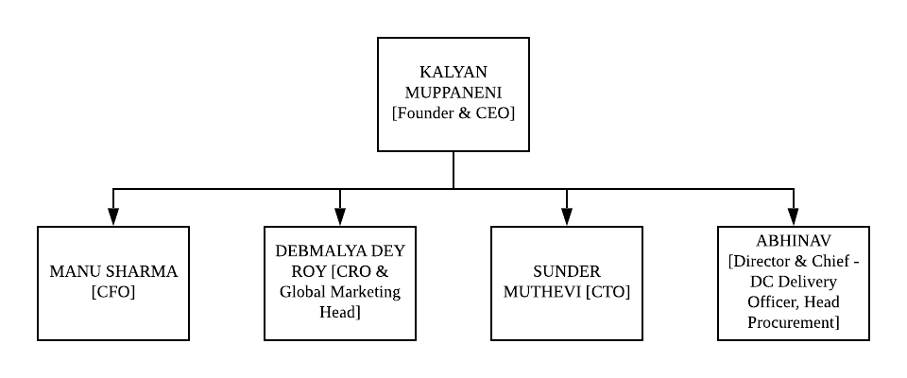**Strategic Management Committee**

**2.6 Management Committee Chart**

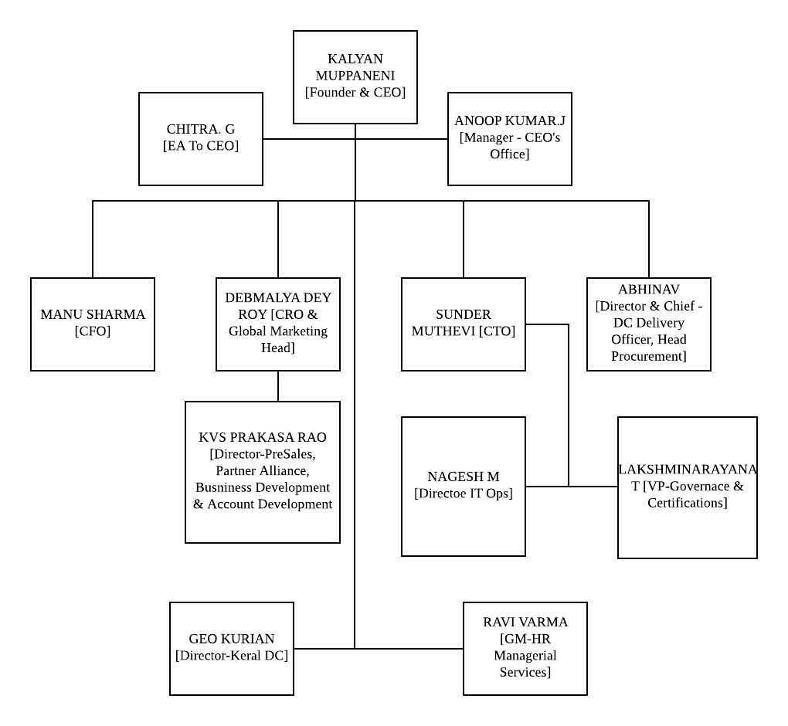

* + 1. **Committee Chart**
  1. **LIST OF PRODUCTS AND SERVICES**

|  |  |  |  |
| --- | --- | --- | --- |
| **PRODUCTS** | **CLOUD SERVICES** | **COLOCATION SERVICES** | **MANAGED SERVICES** |
| SAP | Data Localization | Private Suites | AWS Practice |
| SaaS | Flexibility @core | Whitespace | AZURE Practice |
| Harbor Front (CDN) | Hypervisor of choice | Rack Colocation | VMware Practice |
| Internet Exchange (Ipx) | Scales @will | Sub-Cabinet Services | NOC as a Service |
| Pi Work Spaces | Multi – Tiered Security | Hands and Feet Support | Network as a Service |
|  | 99.9995Percentage Up-Time Availability |  |  |

* 1. **REASONS FOR SUCCESS**

In Pi data firm there is a system called RATE CARD SYSTEM which is excluded from Inflation & Deflation.

Initially prices will be high. Once, the stage where profits earning is started. Then, the rate card system will come into picture. This, Strategy is known as Milking Strategy.

When the customer and Pi holds long duration of relationship in terms of business. Then, the Add-On will be provided to the customer form Pi like by providing L1, L2 services free. Whereas, L3 services are charged.

OPERATIONAL EXCELLENCE (Branch 1): Designing and Planning operations in way that they imply on reduction of cost [50-60Percentage].

PRODUCT LEADERSHIP (Branch 2): Try to drive into market with innovative and creative idea (Challenge Taker) - For Example, Pi has launched Pi passport with the motive to provide E-Mail Solutions. Approx, the success rate of Pi passport is quite less.

CUSTOMER INTIMACY (Branch 3): Services provided according to customer requirement [30-40Percentage: flow of cost - pricing strategy].

Unique services are provided to meet the need of customer’s and too stand in the competitive market.

Usually, the combination of Operational Excellence and Customer Intimacy flow parallelly whose range lies between 70-80Percentage in most cases.

Whereas, Product Leadership lies in between the range 30-20Percentage.

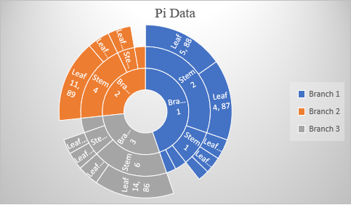

**2.8 Reasons for Success Pi Chart**

* 1. **CONTENDER INDUSTRIES**

Global Competitors are AWS, AZURE, GCP.

Parallel Industries are NextGen, Ctrl S data Centers, Net magic, Din Cloud, TMGcore, Net magic Solutions.

AWS Mission Statement: “Our vision is to be earth's most customer-centric company; to build a place where people can come to find and discover anything they might want to buy online.”

AZURE Mission Statement: Our mission is to empower every person and every organization on the planet to achieve more.

GCP Mission Statement: The mission of Gwinnet County Public Schools is to pursue excellence in academic knowledge, skills, and behaviour for each student, resulting in measured improvement against local, national, and world-class standards.

**2.10 DATA CENTER CONTRIBUTION TOWARDS ECONOMY**

Data traffic has significantly increased as a result of advancements in AI, IoT and smart devices, as well as other data-intensive applications. By 2020, it is predicted that traffic in the world's data centres would have tripled. The scale of data centre development has increased globally due to the increase in data volume.

The slogan "data is the new oil" has gained popularity in recent years as a way to emphasise the enormous value that this commodity from the twenty-first century has amassed. The analogy is still relevant to represent how information is utilised to fuel many contemporary technology applications even if there are a number of significant distinctions between the two resources (for example, unlike oil, data generates more data).

**data factories of the present**

Data centres are the modern-day factories for data that are used by practically all computer organisations, from tiny start-ups to Silicon Valley behemoths. They have developed into economic assets crucial to local, national, and regional economies as a result of the increase in data volume.

According to a survey by the US Department of Commerce, huge data centres directly invest millions of dollars in the local communities, which in turn benefits the surrounding areas. Public infrastructure, such as roads, water utilities, electrical and network infrastructures, as well as construction jobs for the data Centers themselves are all immediately impacted by the initial investment. Once constructed, data centres that operate around-the-clock must be staffed by IT professionals, as well as security and Operating Personnel.

The same trend is supported by numerous reports on the economic impact of data centres, including those from Norway, Finland, the Netherlands, and the United Kingdom. Global investment in data centres reportedly hit $181 million in 2017 and is projected to top $188 million this year, according to Gartner. More than $20 billion was invested in data centres in the USA alone. Real estate investors have also taken notice of data centres, viewing them as significant alternatives to conventional real estate.

**Rules for data localisation and the economic aspect**

In numerous nations around the world, new data localization rules are constantly being developed. The potential for economic growth and development is another reason why some governments are requiring businesses to store their data within the boundaries of national jurisdictions and restricting their ability to transfer locally collected data to other countries, in addition to privacy protection, security, and law enforcement concerns.

The debate centres on whether encouraging data localization through incentives and policies is an effective method to boost the economy, or whether data liberalism would be a preferable alternative. Whereas proponents of data liberalism can claim there are significant efficiency gaps Data protectionists might make an argument using the Hamiltonian and List infant industry lines, which are similar to David Ricardo's theory of comparative advantage (countries continue to trade internationally even when their labour force is more effective at producing goods than labour in other countries) (an emerging industry needs extra protection from international competition). Both claims have fervent defenders.

Economic considerations cannot be disregarded, particularly in areas that gain from direct investment. Governments and the business sector can better prepare for the anticipated increase in global data centre traffic by understanding the effects of data localization requirements and other legal restrictions on the building of data centres.

**2.11 ACHIEVEMENTS OF PI**

**Data center Dynamics (DCD) Recognized Pi as India’s Best Multi-Tenant Data Center Service Provider.**

Bengaluru, 18th July 2019: Pi hits another milestone in its ongoing journey towards perpetuating positive disruption in technology and innovation.

“I am delighted to announce another proud moment Pi as we just got recognized by Data center Dynamics (DCD) for being the Best Multi-Tenant Data Center in India. We will continue to innovate in order to make digital transformation for enterprises easier, faster and TCO optimal”, said Kalyan Muppaneni, Founder & CEO, Pi DATACENTERS.

**Pi was named one of the top 50 great mid-size workplaces in India by the Great Place to Work Institute.**

Mumbai, July 19th, 2019: An enthusiastic atmosphere and applause surrounded the spectacular event that the Great Place to Work Institute threw at the Four Seasons in Mumbai. The greatest mid-sized businesses in India were honoured by the Great Place to Work® Institute (GPTW) for creating high-trust, high-performance workplace cultures.

**The colocation model is rapidly replacing the captive paradigm of data centres in India, according to Kalyan Muppaneni, founder and CEO of Pi.**

“Most of the demand coming currently is geared towards cloud, as clients are clearly looking for speed of delivery and an OPEX model. Given this market scenario, we have several products around cloud offerings. This includes As a Service solution, namely Security as a Service, back up as a Service, Disaster Recovery as a Service, Containers as well as several other customized IaaS and PaaS solutions,” says Kalyan Muppaneni, Founder & CEO –Pi Datacentre’s.

**An interview with Kalyan Muppaneni from the Economic Times recently discussed India's progress toward establishing a $5 trillion GDP.**

The Indian Finance Minister, Mrs. Nirmala Sitharaman, described the Prime Minister's goal of making India a $5 trillion economy and a worldwide economic superpower by 2024–2025 as "difficult" but "realistic" in October of last year.

Kalyan receives the World Leadership Congress's award for CEO of the Year in the information technology sector.

**The World Leadership Congress bestows the prestigious CEO Of the Year Award for the Information Technology Industry on Kalyan Muppaneni, Chairman & CEO of Pi DATACENTERS.**

Deservingly so, Kalyan is a visionary, technology leader and an industry veteran of more than 2 decades, including 15+years in leadership roles with Intel Corporation in the Silicon Valley, US.

He is the creator and driving force behind Harbour, India's first Enterprise Cloud Platform, and Pi DATACENTERS, Asia's largest Uptime Institute Certified TIER IV Data Center

**India’s Best Workplaces for Women 2021**

Hyderabad, 25 September 2021 Pi Data Centers has been named one of the Top 50 - India's Best Workplace for Women 2021 (Mid-size Companies Category) by Great Place to Work® India!

Great Place to Work, a leading authority on workplace culture, has spent more than three decades researching employee experience and people practises in firms. More than 10,000 businesses from more than 60 nations collaborate with the Great Place to Work Institute each year on assessment, benchmarking, and action planning to improve their workplace cultures.

The study carried out in India by Great Place to Work concentrated on the level of workplace trust, the factors that influence employee experience, and how these factors affect company performance. According to the report, there is an obvious and direct connection between employee engagement. The top workplaces routinely exceed India's main stock indices in terms of both financial success and productivity.

* 1. **CORPORATE SOCIAL RESPONSIBILITY**

## **Some of the major PI Industries’ CSR initiatives are as follows:**

* **PI Foundation's Participation in Swachh Bharat Abhiyan Programme:** As part of our Corporate Social Responsibility, PI Industries Ltd. actively participates in the Swachh Bharat Abhiyan Programme of the Government of India and prioritises the provision of household toilets and school restrooms, particularly for girls (CSR).
* **Certified Vocational Training Course on Chemical Plant Operators:** On September 20, 2012, as part of the Vibrant Gujarat 2013 event, PI Industries Ltd. and "The Centre for Entrepreneurship Development," Government of Gujarat, signed an MOU for the creation of skills in the chemical sector.
* **Support for Direct Seeded Rice (DSR)** Technology In order to ensure that all farmers benefit from science-led innovations and to promote the sustainability of the economy, society, and environment, PI is educating policymakers, chambers, universities, nongovernmental organisations (NGOs), and farmers about the Direct Seeded Rice (DSR) Technology.
* [**Farm Engagement Programme**](https://www.piindustries.com/sustainability/Governance/Sustainability-Policy/csr-initiatives#Farm)**:** In the challenging times of early seventies when the country was struggling for food security and was striving hard for ushering in Green Revolution, PI was amongst the first few Indian companies to enter into the business of crop protection chemicals.
* [**Water Conservation through Improved Farm Technology**](https://www.piindustries.com/sustainability/Governance/Sustainability-Policy/csr-initiatives#Water_Conservation)**:** Driven by its corporate philosophy of Bringing Innovations to the Farmers, PI keeps on introducing new technologies and crop solution products to the Indian famers.
* [**Community Development Programme at Plant locations**](https://www.piindustries.com/sustainability/Governance/Sustainability-Policy/csr-initiatives#Plant)**:** PI is assisting the farmers in producing more rice by reducing the quantity and expense of irrigation water in light of the mounting pressure on natural resources like groundwater. Through its partnerships with numerous Japanese businesses, PI has offered the latest post emergent herbicide technology for the rice crop in India.
* [**Protection of National Heritage, Art and Culture**](https://www.piindustries.com/sustainability/Governance/Sustainability-Policy/csr-initiatives#Heritage)**:** Through a special project called "Pichhwai," the PI Foundation is preserving our country's artistic and cultural history.
* [**Academic Recognition**](https://www.piindustries.com/sustainability/Governance/Sustainability-Policy/csr-initiatives#Academic)**:** The Company has recognised innovative research conducted by specialists in the fields of weed science, plant pathology, and plant protection as an ongoing effort for the past few years.
* [**Affirmative Action – Educational Scholarships**](https://www.piindustries.com/sustainability/Governance/Sustainability-Policy/csr-initiatives#Educational)**:** For students from the SC/ST community to complete their education, PI offers financial aid in the form of scholarships.
  1. **CORE CAPABILITIES OF PI**

 The Core Capabilities of Pi Data Centers - Storage, Servers, Network Infrastructure, Computing Resources, Cloud Services, Colocation, Managerial Services.

**2.13 Core Capabilities of Pi**

IV-Tier certification has been to Pi on the basis of the following reasons [few are listed]

* Cloud Hosting: Service Portfolio.
* Cyber Security.
* Disaster Recovery and Business continuity Planning.
* End User Computing.

More than 10,000 businesses from more than 60 nations collaborate with the Great Place to Work Institute each year on assessment, benchmarking, and action planning to improve their workplace cultures. The study carried out in India by Great Place to Work concentrated on the level of workplace trust, the factors that influence employee experience, and how these factors affect company performance. According to the research, there is a strong and direct link between financial performance and employee engagement, and the best workplaces consistently outperform India's major stock indices.

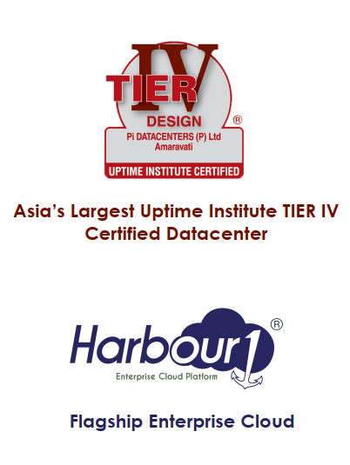

* + 1. **Harbour of Pi**

1. **RESEARCH METHODOLOGY**

**3.1 THEORETICAL FRAMEWORK**



**3.1 Theoretical Framework**

Independent Variable is Talent Acquisition.

* Here, the set of 14 statements data is collected from Human Resource Team who work for Talent Acquisition operations like recruiting, selecting etc.
* 14 statements represent various factors involved in Talent Acquisition such as:
  + Time.
  + Cost.
  + Notice Period.
  + Offer Rejections as such.

Dependent Variable is Employee Attrition.

* Here, the set of 14 statements data is collected from various employees who work in the organization under different departments.
* 14 statements represent various factors involved in Employee Attrition such as:
  + Work Environment.
  + Career Growth.
  + Knowledge Sharing as such.

The predominant outcomes that an enterprise faces in phrases of coping with manpower is worker attrition. Where Employee attrition fee imputes extra on enterprise productivity that indicates the want of controlling and analysing the elements inflicting attrition to make a powerful choice.

Employee attrition implies the proportion of personnel leaving the enterprise. Lack of retention functionality or misinterpretation of the statistics cause the purpose attrition. People analytics entails coping with statistics in phrases of creating interpretations in conjunction with the statistics factors in alignment with the goals to be attained through the enterprise.

It facilitates the enterprise to apprehend better [what is the perception of an employee towards work environment]. Whereas, the software of human’s analytics to the statistics factors of an enterprise due to the fact of worker attrition through task some abilities like Time to Hire, Time to Fill, Quality of Hire which include will offer the answer to controlling the worker attrition and manual the control of the enterprise to make a powerful path of movement to conquer the attrition problem.

Retention has always been a concern for talent teams. Occasionally, retention rate is employed as a proxy for hiring quality because talent teams do not have complete control over all the variables that affect early retention. However, it remains a helpful signal.

Even though they have a number of direct influencers over retention, talent leaders don't always plan their strategy with retention in mind.

This is probably the area where talent acquisition can make the most impact on retention. Instead of hiring for brand names in the candidate’s past experience, or based on the current job openings, more and more talent teams are advising hiring managers on how to hire for skills and development potential.

* 1. **HYPOTHESIS OF THE STUDY**

**H1 -** Talent Acquisition with People Analytics has significant relationship with Employee Attrition.

* 1. **RESEARCH METHODOLOGY**

The broad plan and logic guiding your research are referred to as your methodology. It entails researching the ideas and principles underlying the procedures used in your field in order to create a strategy that is in line with your goals.

It also has analytical components, comparing several approaches to determine the benefits and limitations of each in light of various research objectives and circumstances. By instructing researchers on the approach to use at each stage, a strategy can assist make the research process effective and trustworthy.

Methodology makes the purpose of the research enquiry and its necessity clear. It makes clear the research's beginnings, its goals, and consequently, the potential effects of the research after it is complete.

The techniques or the precise procedure which helps the scholars to

* Identify.
* Choose.
* Process.
* Analyse.

Information a couple of subjects is termed Research Methodology. It allows the readers to judge the validity and reliability of the study within the research paper.

**3.3.1 DESCRIPTION OF THE STUDY AREA**

Employee attrition implies the percentage of employees leaving the organization. Lack of retention capability or misinterpretation of the data lead to the cause attrition.

People analytics involves dealing with data in terms of making interpretations along with the data points in alignment with the objectives to be attained by the organization. It helps the organization to understand better [what is the perception of an employee towards work environment].

Whereas, the application of people analytics to the data points of an organization to draw decision alternatives over employee attrition by undertaking a few competencies like Time to Hire, Time to Fill, Quality of Hire such as will provide the solution to controlling the employee attrition and guide the management of the organization to make an effective course of action to overcome the attrition problem. Tools like Excel, Tableau such as will play a vital role in interpreting the data points.

Proper collection of Data Points, Choice of competencies, Way of interpreting the data, point of making the decision will play a vital role to imputes people analytics in order to control the Employee Attrition Rate.

Positive consequences impute due to employee attrition - Improve organization productivity, Retain Potential Employee. Whereas, Negative consequences are Incurring more cost on Employee Training, More Time consumption.

Thus, this analysis will be a great add-on component to the organization as the Employee Attrition Rate is being fluctuated more during pandemic situations along with to gain an insight on what is the view of employee over the organization (factors leading to leave the organization) will results to increase the employee turnover rate.

**3.3.2 RESEARCH METHOD**

Type of Research used is **“Descriptive Cross - Sectional”** methodology.

Data from a cross-functional descriptive study can be used to describe the status of phenomena or the connections between phenomena at a given period. As a result, this case study offers advice on the practicalities of conducting a descriptive cross-sectional study to evaluate if Talent Acquisition with People Analytics will assist to better manage, decrease, or prevent employee turnover or not.

* **Characteristics of Cross Functional Descriptive Analysis**
* Researchers can carry out a cross-sectional study over a predetermined time period using the same set of variables.
* While similar studies may focus on the same important characteristic, each one includes a different group of subjects.
* Unlike longitudinal studies, where variables can alter over the course of extended research, cross-sectional analysis evaluates themes during a single instance with a fixed start and stopping point.
* Cross-sectional studies give the researcher the opportunity to focus on one independent variable while also examining one or more dependent variables.

**3.3.3 RESEARCH DESIGN**

This Research is carried through **“Descriptive Research Design”** because here the data for analysis is collected only at single time.

**Benefits of Cross Functional** **Descriptive Analysis**

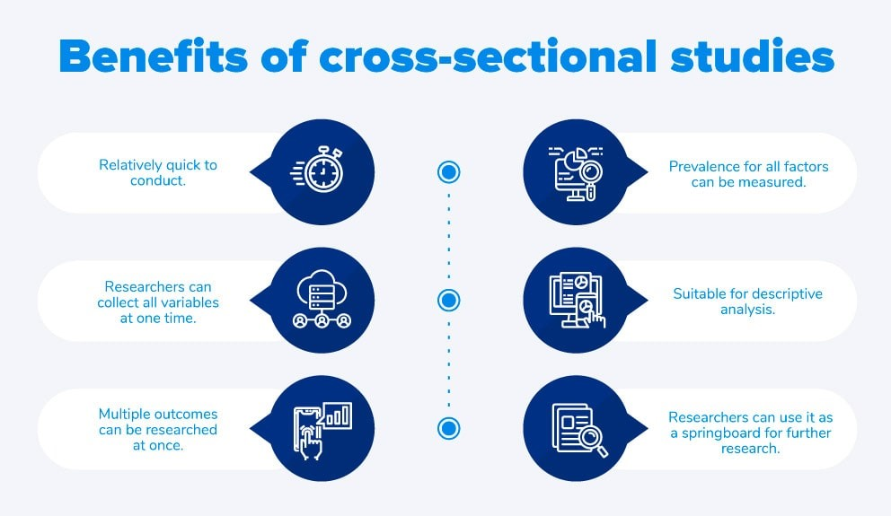

Source: questionpro.com

* + 1. **Benefits of Cross-Sectional Studies**

**3.3.4 SAMPLING TECHNIQUES, SAMPLE SIZE DETERMINATION**

Technique is “**Convenience Sampling”**

strategy used by researchers where they gather data from a pool of respondents who are conveniently available. It is the most often utilised sample technique since it is so quick, simple, and affordable.

Populations that are simple to reach tend to be used for convenience sampling. Researchers can utilise convenience sampling to collect pilot data or investigate a concept that could be tested in subsequent studies because the data is readily available.

**Population:** a comprehensive group of elements (people or objects) sharing a particular trait as determined by the researcher's sample criteria. consisting of the target population and the accessible population. target audience (universe). The population of this study is made up of the 508 total employees of Pi Data Centers.

**Sampling Techniques:** Sampling techniques describe how we choose individuals from the population to participate in the study. If a sample isn't chosen at random, it will likely be skewed in some way, and the results might not be generalizable. There are numerous methods for choosing a sample, both good and bad.

In this research only the Sampling Method used is Survey Sampling.

**Sample size:** The number of subjects involved in a sample size is referred to as the sample size in market research. By sample size, we mean a number of individuals chosen at random from the general population who are thought to be representative of the actual population for that specific study.

* In this research, only 217 Respondents are selected from the wide population.

**3.3.5 SOURCES OF DATA COLLECTION**

COLLECTION OF DATA

**Questionnaire**Structured Questionnaire which consists of close ended and some open-ended questions there are 28 questions that related to the perception of employee towards organisation which lead to attrition rate and its reason the questionnaire is well structured and it consists of closed ended questions. There is a total of 28 questions that aims to cover all aspects of the employee attrition.

Demographics: Six questions (Age, Experience, Martial Status, Income, Gender, Qualification)

The data was collected from two different sources:

1. PRIMARY DATA:

* The Primary data was collected with the help of employees who has worked in the Pi Data Centers Pvt Ltd (Pi) by using the method questionnaire (closed ended).

1. SECONDARY DATA:

* Secondary data is the data that is collected from different sources. It also helps to get elaborate information that is adequate to the study.
* Secondary data has been collected from various sources as mentioned below:
* Company website.
* Internet.
* Blog’s of the company.
* Research papers.

**3.3.6 DATA COLLECTION INSTRUMENTS**

Structured Questionnaire which consists of six demographic variables, 14 statements related to Employee attrition and 14 statements related to Talent Acquisition.

Likert Scales with five-point Scales is used from Strongly Disagree to Strongly Agree. Which helps the survey maker that is researcher to make a holistic view of respondent’s opinion.

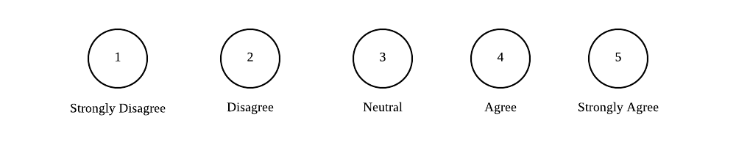

**3.3.6 Point-rating Scales**

Type of Questions are Closed ended.

Mode of Data Collection is Goggle Forms.

* + 1. **MEASUREMENT VARIABLES**

The two-measurement variable are Talent Acquisition, Employee Attrition.

Employee Attrition has 14 statements which measure various factors like Work Environment, Career Opportunities, Knowledge Sharing.

It mainly projects the employee perception on how they get a thought of leaving organization which costs much to the organization. As, saying goes It’s better to retain potential employee rather than hiring a new one. So, it’s better to inculcate the best practices to retain the potential employees.

Talent Acquisition has 14 statements which measure various factors like time, cost, rejections faced during the talent acquisition process implementation.

It mainly projects concerns related to talent acquisition process which costs much the organization. Here, the gaps should be focused like:

* The gap between Qualification of technical round and HR round?
* Duration taken to release the offer letter?
* Time consumed to get Cost approval?

In this research the whether there is significant relation is there or not is tested (between Talent Acquisition and Employee Attrition).

As well people analytics metrics are applied which help to evaluate the existing talent acquisition process. Based on result the further changes can be performed to the process inculcated.

* + 1. **METHOD OF DATA ANALYSIS**

**Correlation** The correlation coefficient, which is stated numerically, illustrates the degree of a relationship between two variables. Values for the correlation coefficient fall between -1.0 and 1.0.

* If there is a perfect positive connection, the correlation coefficient must be precise. This means that the secondary security moves in lockstep, in the same direction, as the first security moves, whether up or down.
* A complete negative correlation indicates that the movements of two assets are in opposition to one another, while a zero correlation indicates that there is no association at all.

**3.3.8 Strength of Relationship in Correlation**

|  |  |
| --- | --- |
| -1.00 | Perfect Negative Correlation |
| -.60 | Strong Negative Correlation |
| -.30 | Moderate Negative Correlation |
| -10 | Weak Negative Correlation |
| .00 | No Correlation |
| +.10 | Weak Positive Correlation |
| +.30 | Moderate Positive Correlation |
| +.60 | Strong Positive Correlation |
| +1.00 | Perfect Positive Correlation |

Correlation is carried out to know the significant relation between Talent Acquisition with Employee Attrition.

* + 1. **DATA RELIABILITY AND DATA VALIDITY**

Reliability test is performed to assure that our analysis is quality-oriented that is the statements which are opted for analysis are working as it is (How it should do).

The reliability test is carried out in SPSS Software as three various aspects:

* + Employee Attrition 14 Statements at once.
  + Talent Acquisition 14 Statements at once.
  + All together 28 Statements at once.

Employee Attrition 14 Statements Reliability

## **3.3.9.1 Case Processing Summary EA**

|  |  |  |  |
| --- | --- | --- | --- |
| N | | | Percentage |
| Cases | Valid | 217 | 99.5 |
| Excludeda | 1 | .5 |
| Total | 218 | 100.0 |

a. Listwise deletion based on all variables in the procedure.

## **3.3.9.1.1 Reliability Statistics of EA**

|  |  |
| --- | --- |
| Cronbach's Alpha | N of Items |
| .874 | 14 |

Talent Acquisition 14 Statements Reliability

## **3.3.9.2 Case Processing Summary TA**

|  |  |  |  |
| --- | --- | --- | --- |
| N | | | Percentage |
| Cases | Valid | 217 | 99.5 |
| Excludeda | 1 | .5 |
| Total | 218 | 100.0 |

1. Listwise deletion based on all variables in the procedure.

## **3.3.9.2.1 Reliability Statistics of TA**

|  |  |
| --- | --- |
| Cronbach's Alpha | N of Items |
| .826 | 14 |

Employee Attrition and Talent Acquisition 28 Statements Reliability

|  |  |  |  |
| --- | --- | --- | --- |
| * + - 1. **Case Processing Summary for EA and TA** | | | |
|  | | N | Percentage |
| Cases | Valid | 217 | 99.5 |
| Excludeda | 1 | .5 |
| Total | 218 | 100.0 |
| 1. Listwise deletion based on all variables in the procedure. | | | |

|  |  |
| --- | --- |
| **3.2.9.3.1 Reliability Statistics for Employee Attrition and TA** | |
| Cronbach's Alpha | N of Items |
| .863 | 28 |

**3.3.9.4 Interpretation of Cronbach’s Alpha value**

|  |  |
| --- | --- |
| **Cronbach’s Alpha value** | **Criteria** |
| Less than 0.5 | Bad |
| Between 0.5 to 0.6 | Ugly |
| Between 0.6 to 0.7 | Enough |
| Between 0.7 to 0.8 | Nice |
| Above 0.8 | Good |

As per the above interpretation of Cronbach’s Alpha value Above 0.8 is Good. The three various aspects Cronbach’s Alpha value in this analysis is:

Employee Attrition 14 Statements Cronbach’s Alpha value is .875

Talent Acquisition 14 Statements Cronbach’s Alpha value is .826

Employee Attrition and Talent Acquisition 28 Statements Cronbach’s Alpha value is .863

**Interpretation:** Three aspects result in Good Cronbach’s Alpha value. That is the statements which are opted for analysis are working as it is (How it should do).

* + 1. **AN OVERVIEW OF RESEARCH METHODOLOGY**

|  |  |
| --- | --- |
| Independent Variable | Talent Acquisition |
| Dependent Variable | Employee Attrition |
| Data Sources | Primary source, Secondary sources |
| Type of Research | Descriptive Cross-Sectional |
| Population | 508 |
| Sampling Unit | Harbour1 |
| Sample Size | 217 |
| Sampling Technique | Convenience |
| Research Instrument | Structured Questionnaire |
| Type of Questions | Closed Ended (five rating Scales -Likert) |
| Mode of Data Collection | Google Forms |
| Statistical Techniques | Central Tendency, Correlation. |
| Software | SPSS |

1. **DATA ANALYSIS AND INTERPRETATIONS**

Here, this project titled A STUDY OF RELATIONSHIP BETWEEN TALENT ACQUISITION WITH EMPLOYEE ATTRITION USING PEOPLE ANALYTICS is carried out for analysis and interpretation over two scenarios. They are:

* Employee Scenario (What make them develop the thought to leave the organisation - does it has any relation with talent acquisition).
* Employer Scenario (What are the metrics used to evaluate current talent acquisition process and make it effective).

To carry out first scenario that is Employee Scenario (What make them develop the thought to leave the organisation - does it has any relation with talent acquisition) a questionnaire is been circulated to employees who work in Pi data in which different questions were asked like What is their opinion about organisation, Superior relationship, Policies that are needed to be revised etc. From, that data the accurate information is taken which means by deleting duplicate respondents or any irrelevant responses recorded. To ensure the accuracy of information which is considered further for interpretations in order to draw various measures and conclusion to reduce, control employee attrition in the organisation.

To carry out second scenario that is Employer Scenario (What are the metrics used to evaluate current talent acquisition process and make it effective). The method followed is one - on - one interaction with the General Manager - HR & Managed services [Ravi Varma] of Pi data. In the process of interaction, the context of company related to employee attrition and factors causing it have been observed. As, it is difficult to analyse all departments in the organisation I have considered only IT-ops.

The list of employees who work for It-ops department with their join dates, new hires in that department, number of replacements over one year that is from march, 2021 to march, 2022. To that data the competencies like time to hire, time to fill etc were calculated to know how effective the recruitment and selection process is (as it also influences the attrition rate). Along with the other parameters to determine why there are more fluctuations in employee attrition rate in IT-ops at Pi data.

**Age**

|  |  |  |
| --- | --- | --- |
| **Range** | **No. of Respondents** | **Percentage** |
| 18-28 | 103 | 55.6 |
| 29-39 | 60 | 22.2 |
| 40-50 | 30 | 14.8 |
| 51-60 | 24 | 7.4 |
| **TOTAL** | **217** | **100** |

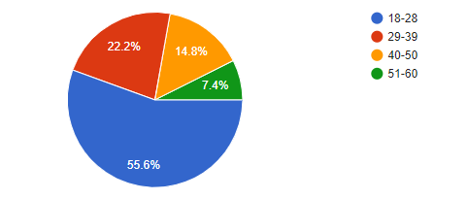

**Interpretation:**

From the above analysis it is interpreted that 55.6Percentage employees that is more than half the count is between the age 18-28. By which the positive scenario can be led is a young innovative blood will help the organization to create miracles at the same there is a chance that their mind gets fluctuated easily and opt for other better options (with more compensation as such).

**Gender**

|  |  |  |
| --- | --- | --- |
| **Options** | **No. of Respondents** | **Percentage** |
| Female | 112 | 51.9 |
| Male | 105 | 48.1 |
| Don’t Want to Mention | 0 | 0 |
| **TOTAL** | **217** | **100** |

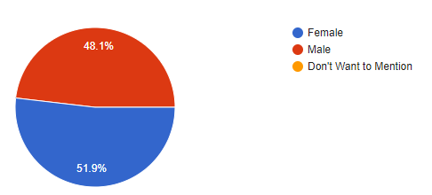

**Interpretation:**

From the above observations it is observed that 51.9Percentage employees tend to be females which is good count that shows female can also work equally with men. It’s quite important for the organization to focus more on practices they implement in the workplace because when the female count is more there is a need to follow some special practices like creches, medical rooms (during their cycle period) as such which make them to hold loyalty towards organization and stay there.

**Qualification**

|  |  |  |
| --- | --- | --- |
| **Options** | **No. of Respondents** | **Percentage** |
| Under Graduation | 170 | 77.8 |
| Post-Graduation | 47 | 22.2 |
| **TOTAL** | **217** | **100** |

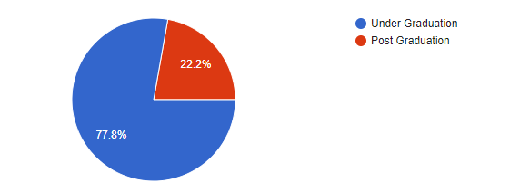

**Interpretation:**

From the above analysis it is interpreted that 77.8Percentage employees in the organization are under graduation. The company can focus more on their career growth by providing them a chance to pursue the post-graduation parallelly while working with some underlying norms by which company can make employee feel good and proud in terms of working in the organization which thinks about employee growth along with organizational growth.

**Experience**

|  |  |  |
| --- | --- | --- |
| **Range** | **No. of Respondents** | **Percentage** |
| 0-2 | 0 | 0 |
| 3-5 | 152 | 70.4 |
| 6-10 | 24 | 11.1 |
| 11-15 | 17 | 7.4 |
| 16-25 | 24 | 11.1 |
| **TOTAL** | **217** | **100** |

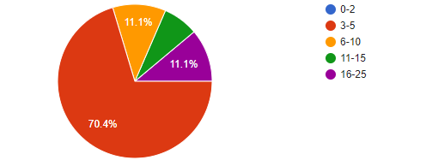

**Interpretation:**

It is observed that 70.4Percentage employees hold 3-5 years of experience. Which mean there is need for organizations to focus more into training and development sessions in order to keep them updated with skills on time based on work requirement or else employee may shift to other organizations after learning the skill in present organization. If organization fail to do so employees tend to migrate from this organization to another in search of new skills and knowledge.

**Income**

|  |  |  |
| --- | --- | --- |
| **Range** | **No. of Respondents** | **Percentage** |
| 5,000 - 20,000 | 0 | 0 |
| 21,000 - 35,000 | 9 | 3.7 |
| 36,000 - 50,000 | 136 | 63 |
| 50,000 Above | 70 | 33.3 |
| **TOTAL** | **217** | **100** |

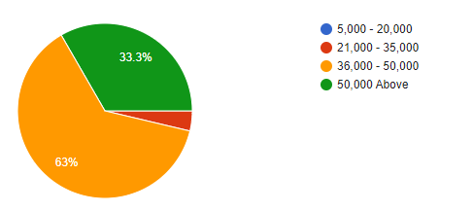

**Interpretation:**

Analysis show that 63Percentage of employee’s income is between 36,000 INR to 50,000 INR which is a good Scales to some extent as this organization hold more 3-5 years experienced employees. But it should be revised on equal intervals on the basis on performance score that employee scored in the evaluation criteria. So, then it encourages better performance and motivates the low performer which is for good cause.

**Marital Status**

|  |  |  |
| --- | --- | --- |
| **Options** | **No. of Respondents** | **Percentage** |
| Married | 112 | 51.9 |
| Single | 105 | 48.1 |
| Don’t Want to Mention | 0 | 0 |
| **TOTAL** | **217** | **100** |

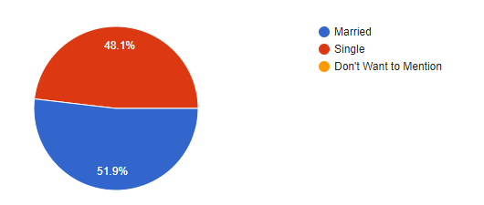

**Interpretation:**

It is observed that 51.9Percentage employees are married which mean there is a need of work-life balance to differentiate the personal and professional life. As well the rest are un married in order to keep them engaged at work place there is a need to organization to come up with a innovative and fun based practices. In this manner the both married and unmarried employees can be engaged at workplace.

**4.1 FIRST SCENARIO CORRELATION [Employee] -** What make them develop the thought to leave the organisation - does it has any relation with talent acquisition

**Q. No 1:** Organization Working Environment is Good?

|  |  |  |
| --- | --- | --- |
| **Scales** | **No. of Respondents** | **Percentage** |
| Strongly Agree | 166 | 76.5 |
| Agree | 41 | 18.9 |
| Neutral | 5 | 2.3 |
| Disagree | 2 | 0.9 |
| Strongly Disagree | 3 | 1.4 |
| **Total** | **217** | **100** |

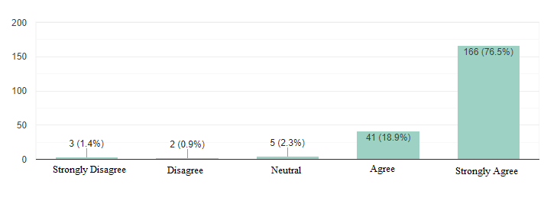

**Interpretation:**

From the above bar graph it is observed that 76.5Percentage of the Employees Strongly Agreed that Organization Working Environment is Good. As, the working environment will help the employee to generate the opinion about the organisation either positive or negative it plays a vital role to retain the employee. So, there is a need for organizations to take working environment as one of the focal points to be considered.

**Q. No 2:** The Company need to Revise its Leave Policy?

|  |  |  |
| --- | --- | --- |
| **Scales** | **No. of Respondents** | **Percentage** |
| Strongly Agree | 127 | 58.5 |
| Agree | 78 | 35.9 |
| Neutral | 6 | 2.8 |
| Disagree | 5 | 2.3 |
| Strongly Disagree | 1 | 0.5 |
| **Total** | **217** | **100** |

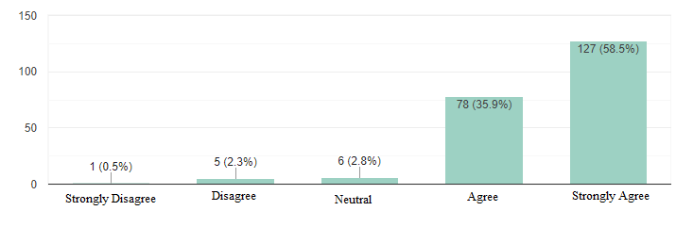

**Interpretation:**

From above bar graph it is observed that 58.5Percentage Employees Strongly Agreed there is a need to revise the leave policy. Leave policy is one of the policies in the organization that motivate the employees as well as it helps the organization to imputes its concern towards employees. But, revising a leave policy is quite bigger thing for organizations it has a procedure to enact the revision in the existing one.

**Q. No 3:** The Company Encourages Knowledge Sharing among Employees?

|  |  |  |
| --- | --- | --- |
| **Scales** | **No. of Respondents** | **Percentage** |
| Strongly Agree | 131 | 60.4 |
| Agree | 75 | 34.6 |
| Neutral | 9 | 4.1 |
| Disagree | 1 | 0.5 |
| Strongly Disagree | 1 | 0.5 |
| **Total** | **217** | **100** |

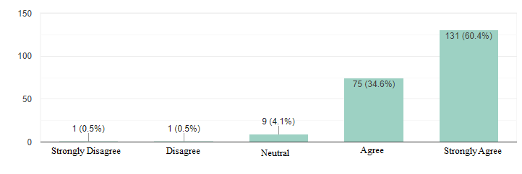

**Interpretation:**

From, the above bar graph Analysis it is interpreted that 60.4Percentage of employees Strongly Agreed that the organization encourage them to share knowledge with the co-workers. As, Knowledge sharing is one the key aspect which helps them to keep connected, perform better and become better in the aspect of being professional.

**Q. No 4:** My Colleagues believe in Team Work?

|  |  |  |
| --- | --- | --- |
| **Scales** | **No. of Respondents** | **Percentage** |
| Strongly Agree | 137 | 63.1 |
| Agree | 64 | 29.5 |
| Neutral | 11 | 5.1 |
| Disagree | 5 | 2.3 |
| Strongly Disagree | 0 | 0.0 |
| **Total** | **217** | **100** |

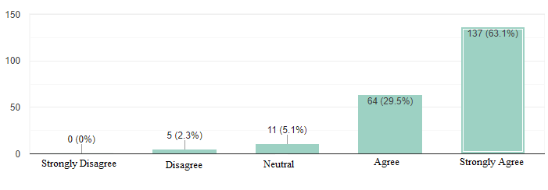

**Interpretation:**

As, per the above bar graph analysis it is observed that 63.1Percentage of employees at organization believe in teamwork. But, if the observations tend to project lack of believe in team work it is a concerned point to employer which is to be focused because team work will encourage personal growth, helps in attaining job satisfaction and reduce the work stress.

**Q. No 5:** I Actively Engage in Networking at Workplace?

|  |  |  |
| --- | --- | --- |
| **Scales** | **No. of Respondents** | **Percentage** |
| Strongly Agree | 130 | 59.9 |
| Agree | 73 | 33.3 |
| Neutral | 9 | 4.1 |
| Disagree | 3 | 1.4 |
| Strongly Disagree | 2 | 0.9 |
| **Total** | **217** | **100** |

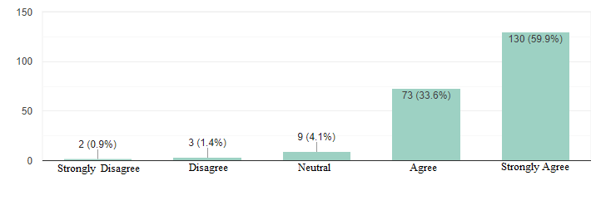

**Interpretation:**

The bar graph projects that 59.9Percentage say that networking at workplace is welly managed in the organization. Because it is important to have proper networking channel at workplace as it contributes to the individual social well-being and promote exchange of ideas. As ell it helps in boosting the employee confidence at workplace and stand stable.

**Q. No 6:** My supervisor provides the actionable suggestions on what level an employee can do to improve?

|  |  |  |
| --- | --- | --- |
| **Scales** | **No. of Respondents** | **Percentage** |
| Strongly Agree | 131 | 60.4 |
| Agree | 74 | 34.1 |
| Neutral | 9 | 4.1 |
| Disagree | 1 | 0.5 |
| Strongly Disagree | 2 | 0.9 |
| **Total** | **217** | **100** |

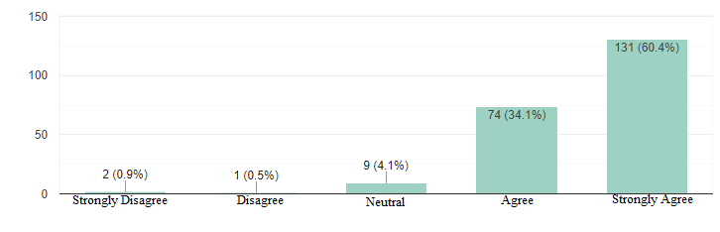

**Interpretation:**

From the above bar graph, it is observed that 60.4Percentage of employees accept that superior tend to suggest the possible ways to make employee improve better which keep the employee engaged at workplace as well to be more productive.

**Q. No 7:** I take initiative in helping my colleagues?

|  |  |  |
| --- | --- | --- |
| **Scales** | **No. of Respondents** | **Percentage** |
| Strongly Agree | 119 | 54.8 |
| Agree | 78 | 35.9 |
| Neutral | 13 | 6 |
| Disagree | 4 | 1.8 |
| Strongly Disagree | 3 | 1.4 |
| **Total** | **217** | **100** |

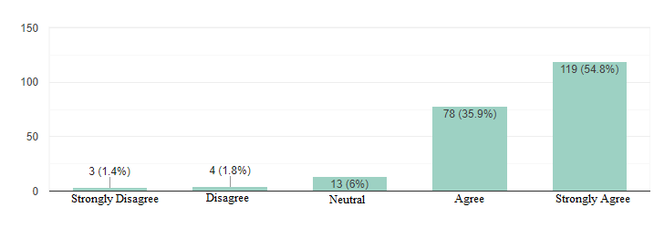

**Interpretation:**

As, per the bar graph analysis it is observed that 54.8Percentage of employees at organization believe in helping the colleagues. But, a new opportunity for improvement within your workplace will encourage personal growth, helps in learning more.

**Q. No 8:** I am satisfied with the current working conditions?

|  |  |  |
| --- | --- | --- |
| **Scales** | **No. of Respondents** | **Percentage** |
| Strongly Agree | 138 | 63.6 |
| Agree | 69 | 31.8 |
| Neutral | 7 | 3.2 |
| Disagree | 2 | 0.9 |
| Strongly Disagree | 1 | 0.5 |
| **Total** | **217** | **100** |

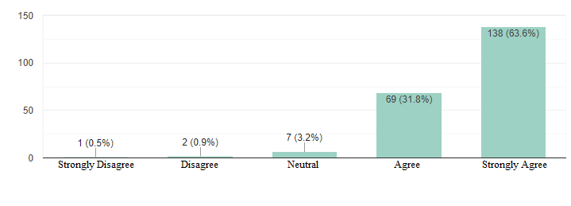**Interpretation:**

From the above bar graph the observations are 63.6 Percentage of employees are satisfied with current working conditions as the employees are well recognized with their contribution towards the company along with a good terms and conditions of the work place.

**Q. No 9:** My ideas are well taken by my supervisor?

|  |  |  |
| --- | --- | --- |
| **Scales** | **No. of Respondents** | **Percentage** |
| Strongly Agree | 114 | 52.5 |
| Agree | 87 | 40.1 |
| Neutral | 9 | 4.1 |
| Disagree | 5 | 2.3 |
| Strongly Disagree | 2 | 0.9 |
| **Total** | **217** | **100** |

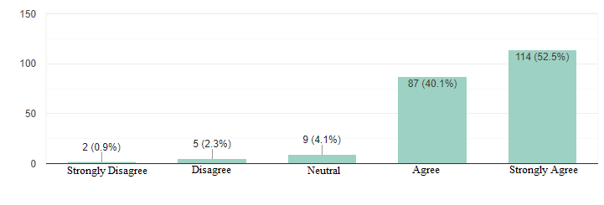

**Interpretation:**

From the above bar graph analysis, it is observed that 52.5Percentage accept that supervisor tend to take ideas and try to implement them in best possible ways to make better growth to organization as well as employee to keep them engaged at workplace as well to be more productive.

**Q. No 10:** The company management understands its employees?

|  |  |  |
| --- | --- | --- |
| **Scales** | **No. of Respondents** | **Percentage** |
| Strongly Agree | 136 | 62.7 |
| Agree | 68 | 31.3 |
| Neutral | 8 | 3.7 |
| Disagree | 2 | 0.9 |
| Strongly Disagree | 3 | 1.4 |
| **Total** | **217** | **100** |

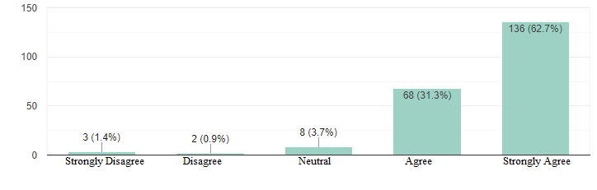

**Interpretation:**

From the above bar graph it is observed that 62.7Percentage foe employee say that management tend to take good care of their employees in the possible ways to make employee and employer relationship stronger which help them to retain in the organization for long period of time.

**Q. No 11:** I prefer to work from home?

|  |  |  |
| --- | --- | --- |
| **Scales** | **No. of Respondents** | **Percentage** |
| Strongly Agree | 81 | 37.3 |
| Agree | 67 | 30.9 |
| Neutral | 66 | 30.4 |
| Disagree | 2 | 0.9 |
| Strongly Disagree | 1 | 0.5 |
| **Total** | **217** | **100** |

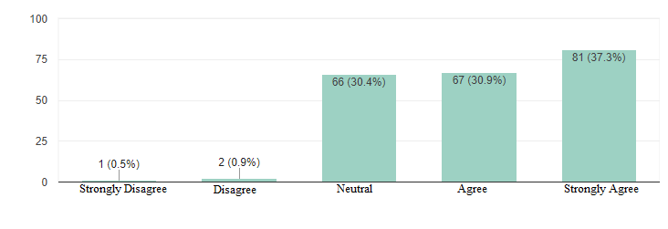

**Interpretation:**

From the above observations it is observed that 37.3Percentage of employees prefer to work from home as it reduces the travelling time and can improve the productive time with comfort of spending quality time with family.

**Q. No 12:** My company provides opportunities for career growth of its employees?

|  |  |  |
| --- | --- | --- |
| **Scales** | **No. of Respondents** | **Percentage** |
| Strongly Agree | 135 | 62.2 |
| Agree | 65 | 30 |
| Neutral | 13 | 6 |
| Disagree | 1 | 0.5 |
| Strongly Disagree | 3 | 1.4 |
| **Total** | **217** | **100** |

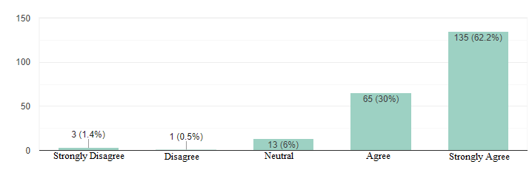

**Interpretation:**

From the above bar graph analysis, it is interpreted that 62.2Percentage of employees accept that the organization provides growth opportunities to employees by career counselling, inter department transfer leading to knowledge growth, providing training programmes, conferences with industry experts.

**Q. No 13:** My company provides training opportunities to its employees?

|  |  |  |
| --- | --- | --- |
| **Scales** | **No. of Respondents** | **Percentage** |
| Strongly Agree | 124 | 57.1 |
| Agree | 79 | 36.4 |
| Neutral | 8 | 3.7 |
| Disagree | 4 | 1.8 |
| Strongly Disagree | 2 | 0.9 |
| **Total** | **217** | **100** |

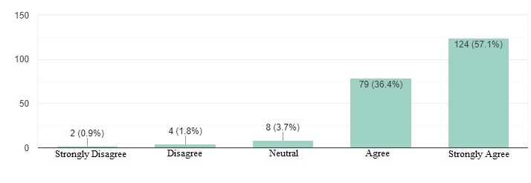

**Interpretation:**

As, per the bar graph analysis it is observed that 57.1Percentage employees say that they are provided with on the job training, simulation training, and various other programmes which lead to growth of the employees as well as improvement of the organization’s employee’s retention.

**Q. No 14:** Company provides fair salary for the work performed by you?

|  |  |  |
| --- | --- | --- |
| **Scales** | **No. of Respondents** | **Percentage** |
| Strongly Agree | 140 | 64.5 |
| Agree | 62 | 28.6 |
| Neutral | 11 | 5.1 |
| Disagree | 1 | 0.5 |
| Strongly Disagree | 3 | 1.4 |
| **Total** | **217** | **100** |

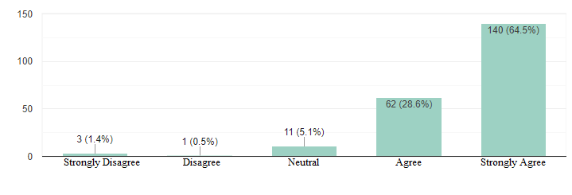

**Interpretation:**

As per the bar graph analysis, we can understand that 64.5Percentage employees say that the organization is providing the salary as per their work. Salary is the key component to motivate employees and keep them within the organization.

**Q. No 15:** Cost and Time are the most difficult requirements to fulfil a position?

|  |  |  |
| --- | --- | --- |
| **Scales** | **No. of Respondents** | **Percentage** |
| Strongly Agree | 167 | 77 |
| Agree | 48 | 22.1 |
| Neutral | 0 | 0.0 |
| Disagree | 2 | 0.9 |
| Strongly Disagree | 0 | 0.0 |
| **Total** | **217** | **100** |

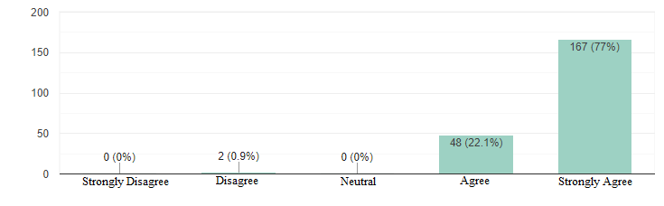

**Interpretation:**

As per the analysis bar graph it is observed that 77Percentage of employees say it is difficult to fulfil a position because the cost involved in training the candidate and placing them in an accurate position is the most difficult task to the recruiter.

**Q. No 16:** The "Green Flags" for a given job requirement is required to be assed? [Green Flags are like Domain Knowledge, Practical Exposure, Certifications]?

|  |  |  |
| --- | --- | --- |
| **Scales** | **No. of Respondents** | **Percentage** |
| Strongly Agree | 126 | 58.1 |
| Agree | 85 | 39.2 |
| Neutral | 4 | 1.8 |
| Disagree | 1 | 0.5 |
| Strongly Disagree | 1 | 0.5 |
| **Total** | **217** | **100** |

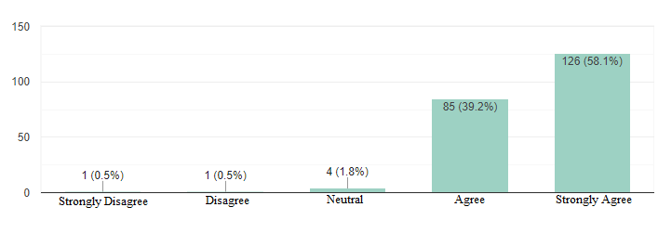

**Interpretation:**

As per the bar graph analysis it can be observed 58.1Percentage accept that green flags are needed to assess the capability of the candidate in the process of hiring to check whether the person is a best fit or not. It is easier to identity the relevant skills of candidate to open position to match the job.

**Q. No 17:** Lack of Experience or Practical Exposure is of the root cause for rejecting candidates for a job requirement?

|  |  |  |
| --- | --- | --- |
| **Scales** | **No. of Respondents** | **Percentage** |
| Strongly Agree | 128 | 59 |
| Agree | 84 | 38.7 |
| Neutral | 2 | 0.9 |
| Disagree | 2 | 0.9 |
| Strongly Disagree | 1 | 0.5 |
| **Total** | **217** | **100** |

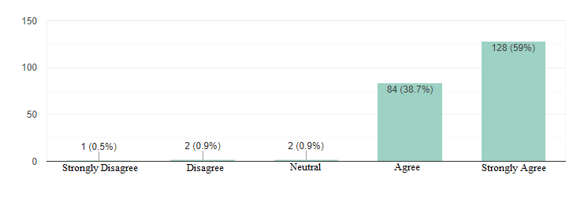

**Interpretation:**

As per the bar graph, it is observed 59Percentage accept that most of the employees are chosen either based on experience or the practical exposure which they are having. As the company can save the cost which are associated while hiring a fresher.

**Q. No 18:** Notice Period is root cause for rejecting candidates for a job requirement?

|  |  |  |
| --- | --- | --- |
| **Scales** | **No. of Respondents** | **Percentage** |
| Strongly Agree | 120 | 55.3 |
| Agree | 90 | 41.5 |
| Neutral | 6 | 2.8 |
| Disagree | 0 | 0.0 |
| Strongly Disagree | 1 | 0.5 |
| **Total** | **217** | **100** |

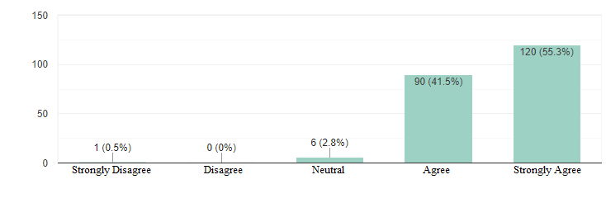

**Interpretation:**

As per the bar graph analysis, it is found 55.3Percentage accept that employees are losing the job opportunities because of the long notice periods of the present working companies which are making the employees to lose the available opportunities with other companies.

**Q. No 19:** Candidates tend to reject offer due to Compensation?

|  |  |  |
| --- | --- | --- |
| **Scales** | **No. of Respondents** | **Percentage** |
| Strongly Agree | 131 | 60.4 |
| Agree | 80 | 36.9 |
| Neutral | 4 | 1.8 |
| Disagree | 1 | 0.5 |
| Strongly Disagree | 1 | 0.5 |
| **Total** | **217** | **100** |

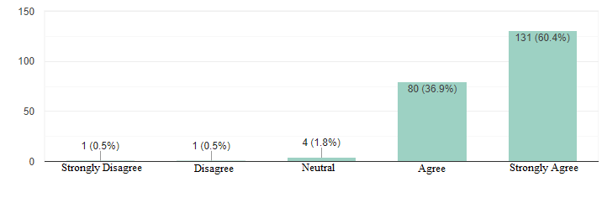

**Interpretation:**

According to the plotted bar graph it is observed that 60.4Percentage accept that the candidates reject the offers due to the compensation which they are offered. If the candidate feels he has more opportunities where he can get better compensation.

**Q. No 20:** The Candidates MAY reject offer when there is Lack of Career Growth Opportunities in the Organization?

|  |  |  |
| --- | --- | --- |
| **Scales** | **No. of Respondents** | **Percentage** |
| Strongly Agree | 130 | 59.9 |
| Agree | 80 | 36.9 |
| Neutral | 5 | 2.3 |
| Disagree | 1 | 0.5 |
| Strongly Disagree | 1 | 0.5 |
| **Total** | **217** | **100** |

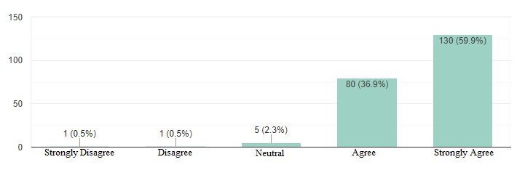

**Interpretation:**

Bar graph analysis project that 59.9Percentage accept that candidates are rejecting the companies based on their past performances as they deem that their growth in the organization cannot meet the satisfaction levels of the candidate when compared with other companies.

**Q. No 21:** Job profile doesn't match the Task Environment lead to early rejection by the candidate?

|  |  |  |
| --- | --- | --- |
| **Scales** | **No. of Respondents** | **Percentage** |
| Strongly Agree | 128 | 59 |
| Agree | 78 | 35.9 |
| Neutral | 7 | 3.2 |
| Disagree | 4 | 4 |
| Strongly Disagree | 0 | 0 |
| **Total** | **217** | **100** |

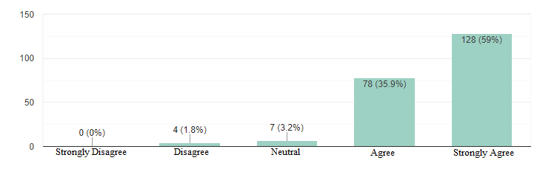

**Interpretation:**

As per the bar graph analysis, the 59Percentage accept that candidates are rejecting the job offer due to mismatch of the job profile with the task environment in which they are going to work. As the actual work does not match with role and responsibilities given in job profile.

**Q. No 22:** Lengthy Interview process lead to loss interest on the job which cause rejection of offer by the candidate?

|  |  |  |
| --- | --- | --- |
| **Scales** | **No. of Respondents** | **Percentage** |
| Strongly Agree | 117 | 53.9 |
| Agree | 86 | 39.6 |
| Neutral | 9 | 4.1 |
| Disagree | 3 | 1.4 |
| Strongly Disagree | 2 | 0.9 |
| **Total** | **217** | **100** |

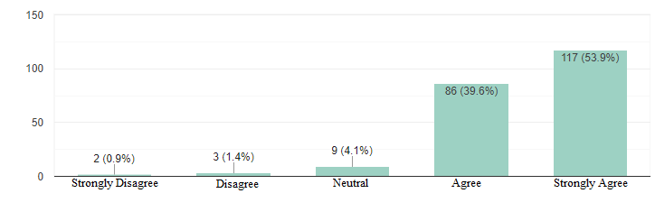

**Interpretation:**

According to the bar graph analysis of the data it is found 53.9Percentage accept that most of the candidates are losing the interest in proceeding with the job process due to lengthy process and are going to find other possibilities in other companies.

**Q. No 23:** In-Bucket Provide "good candidates" that is high quality candidates in large number with high hit rate?

|  |  |  |
| --- | --- | --- |
| **Scales** | **No. of Respondents** | **Percentage** |
| Strongly Agree | 137 | 63.1 |
| Agree | 72 | 33.2 |
| Neutral | 5 | 2.3 |
| Disagree | 3 | 1.4 |
| Strongly Disagree | 0 | 0.0 |
| **Total** | **217** | **100** |

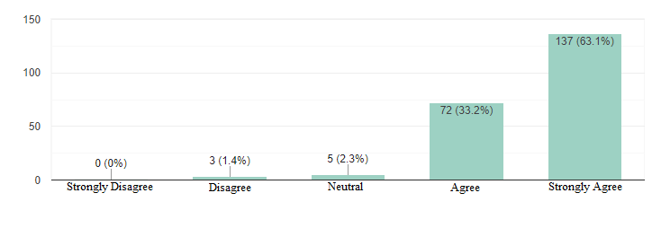

**Interpretation:**

As per the bar graph analysis, 63.1Percentage accept that candidates with high skills are having the maximum impact on the productivity of the company leading to success of the organization. And the hit rate is also high with the highly qualified candidates.

**Q. No 24:** The optimal aspects while framing sourcing plan through various channels are Time and Cost?

|  |  |  |
| --- | --- | --- |
| **Scales** | **No. of Respondents** | **Percentage** |
| Strongly Agree | 134 | 61.8 |
| Agree | 74 | 34.1 |
| Neutral | 6 | 2.8 |
| Disagree | 2 | 0.9 |
| Strongly Disagree | 1 | 0.5 |
| **Total** | **217** | **100** |

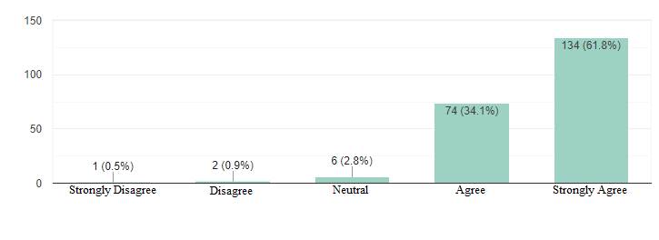

**Interpretation:**

As per the analysis of bar graph it is found 61.8Percentage accept large amount of time and costs are involved in hiring of various candidates through multiples channels which involves associated costs and filtering time for choosing the optimal candidates and selecting them.

**Q. No 25:** Time and Cost are the Bottlenecks in Talent Acquisition process?

|  |  |  |
| --- | --- | --- |
| **Scales** | **No. of Respondents** | **Percentage** |
| Strongly Agree | 136 | 62.7 |
| Agree | 74 | 34.1 |
| Neutral | 6 | 2.8 |
| Disagree | 1 | 0.5 |
| Strongly Disagree | 0 | 0.0 |
| **Total** | **217** | **100** |

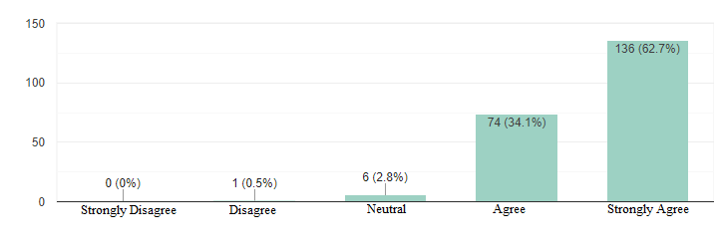

**Interpretation:**

According the analysis of bar graph, it was found 62.7Percentage accept that time given to fill the vacant position was short and the cost involved to hire the right candidate was high and this whole process is causing bottlenecks.

**Q. No 26:** Sourcing and Short-Listing are the Bottlenecks in Talent Acquisition process?

|  |  |  |
| --- | --- | --- |
| **Scales** | **No. of Respondents** | **Percentage** |
| Strongly Agree | 130 | 59.9 |
| Agree | 81 | 37.3 |
| Neutral | 4 | 1.8 |
| Disagree | 2 | 0.9 |
| Strongly Disagree | 0 | 0.0 |
| **Total** | **217** | **100** |

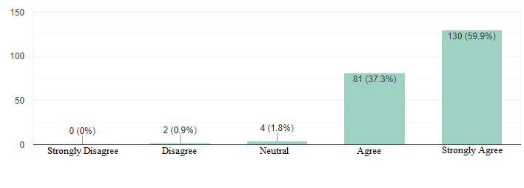

**Interpretation:**

As per the analysis of bar graph 59.9Percentage accept that shortlisting the candidates form sourcing stage is creating a slowdown in whole process and causing the candidates to lose interest and make them to move to other variable options.

**Q. No 27:** Selecting is the Bottleneck in Talent Acquisition process?

|  |  |  |
| --- | --- | --- |
| **Scales** | **No. of Respondents** | **Percentage** |
| Strongly Agree | 116 | 53.5 |
| Agree | 91 | 41.9 |
| Neutral | 7 | 3.2 |
| Disagree | 2 | 0.9 |
| Strongly Disagree | 1 | 0.5 |
| **Total** | **217** | **100** |

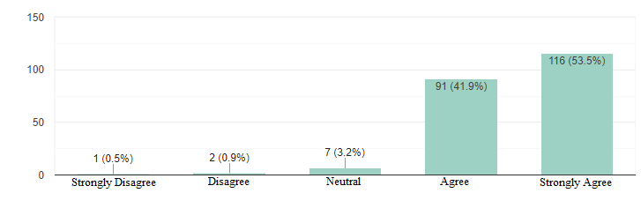

**Interpretation:**

As per the analysis of bar graph it is observed 53.5Percentage accept that, selecting the candidates from the bunch of applicants is creating a delay in time taken to move to further process leading to bottleneck as drop in processing performance of selection.

**Q. No 28:** Offer Accepting and Joining are the Bottlenecks in Talent Acquisition process?

|  |  |  |
| --- | --- | --- |
| **Scales** | **No. of Respondents** | **Percentage** |
| Strongly Agree | 137 | 63.1 |
| Agree | 68 | 31.3 |
| Neutral | 9 | 4.1 |
| Disagree | 2 | 0.9 |
| Strongly Disagree | 1 | 0.5 |
| **Total** | **217** | **100** |

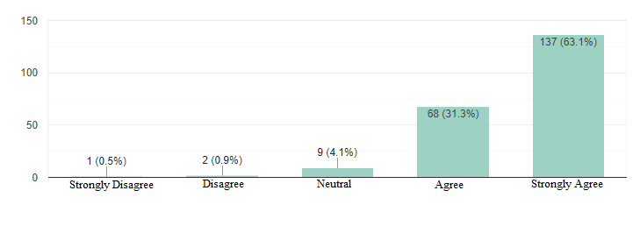

**Interpretation:**

From the above bar graph it was found 63.1Percentage accept that the time gap between the offer acceptance and time of joining is more and which is creating a bottleneck in organization as there is no accurate information relating to number of vacancies in cases of large companies are hiring are going on continuously and vacant position may not be clearly and readily available with management.

The Means and Standard Deviation of total 28 questions under the classification heads of Talent Acquisition (14 Questions) and Employee Attrition (14 Questions).

**4.1.1 Descriptive Statistics**

|  |  |  |  |
| --- | --- | --- | --- |
|  | Mean | Std. Deviation | N |
| Employee Attrition | 63.5 | 4.3 | 217 |
| Talent Acquisition | 63.9 | 4.1 | 217 |

As, H1 Alternative Hypothesis states that **“Talent Acquisition has significance relationship with Employee Attrition.”**

A Correlation is Performed Between the Talent Acquisition (14 Questions) and Employee Attrition (14 Questions) Analysis.

**4.1.2 Correlation Table**

|  |  |  |  |
| --- | --- | --- | --- |
|  | | Employee Attrition | Talent Acquisition |
| Employee Attrition | Pearson Correlation | 1 | .734** |
| Sig. (2-tailed) |  | .000 |
| N | 217 | 217 |
| Talent Acquisition | Pearson Correlation | .734** | 1 |
| Sig. (2-tailed) | .000 |  |
| N | 217 | 217 |

|  |
| --- |
| **. Correlation is significant at the 0.01 level (2-tailed). |

**Interpretation:**

From the above table of correlation identified that there is a significant strong positive correlation {R=0.734, p<0.01} at 1% level of significance.

Hence, The H1 hypothesis is Accepted at 0.01Percentage level of significance.

The plot is built with the help of Jamovi Software

## Plot

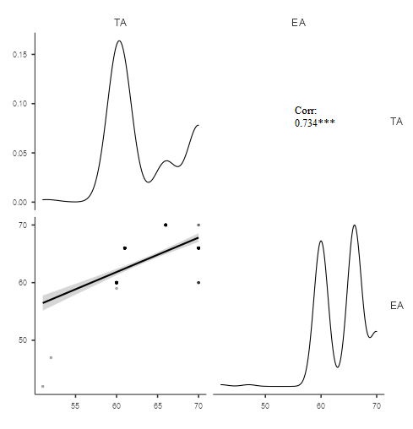

**4.1.2.1 Correlation Plot**

**4.2 SECOND SCENARIO APPLICATION OF PEOPLE ANALYTICS METRICS [Employer]**

To carry out second scenario that is Employer Scenario (What are the metrics used to evaluate current talent acquisition process and make it effective). The method followed is one - on - one interaction with the General Manager - HR & Managed services [Ravi Varma] of Pi data. In the process of interaction, the context of company related to employee attrition and factors causing it have been observed. As, it is difficult to analyse all departments in the organisation I have considered only IT-ops [Information Technology Operations] Department.

**4.2.1 LIST OF IT_OPS IN PI DATACENTERS (41 Count)**

|  |  |  |  |  |  |
| --- | --- | --- | --- | --- | --- |
| **EMP ID** | **Full Name** | **DoJ** | **Designation** | **Grade** | **Domain** |
| Pi00074 | Shaik Bajiba | 19-Oct-16 | Network Engineer | L2 | Networking |
| Pi00077 | Uppalapati Mahitha | 02-Jan-17 | Storage Engineer | L1 | Storage |
| Pi00123 | Gollapudi Sudharshan Chakravarthi | 03-Jul-17 | Network Engineer | L2 | Networking |
| Pi00158 | G V S Kameswararao | 11-Dec-17 | Manager-Networking | Manager | Networking |
| Pi00159 | Arja Durga Prasad | 21-Dec-17 | Cloud Support Engineer | L1 | Compute |
| Pi00183 | Raja Pual Kishore Pamidipalli | 21-Jun-18 | General Manager - IT OPS | AM | GM |
| Pi00207 | Kakarla Srinivasa Gopal | 01-Oct-18 | Network Trainee | L2 | Networking |
| Pi00208 | Gurram Sunilteja | 01-Oct-18 | Cloud Support Engineer | L2 | Compute |
| Pi00211 | Srinivas Amujuri | 03-Oct-18 | Sr. Network Engineer | L3 | Networking |
| Pi00244 | Bhupathi Raju Ravi | 29-Apr-19 | NOC Engineer | L1 | NOC |
| Pi00252 | Doppalapudi Pushpa | 21-May-19 | NOC Engineer | L1 | NOC |
| Pi00273 | Kurra.Sai Sekhar | 02-Dec-19 | Server Administrator | L1 | Administration |
| Pi00281 | Baji Narasimha Raju | 22-Jan-20 | Network Engineer | L1 | Networking |
| Pi00299 | Manam Harika Naidu | 22-Jul-20 | NOC Engineer | L1 | NOC |
| Pi00300 | Mukesh Babu Vemulakonda | 22-Jul-20 | NOC Engineer | L1 | NOC |
| Pi00305 | Phaneendra Bade | 17-Aug-20 | NOC Engineer | L1 | NOC |
| Pi00313 | Madhura Ashok Varma | 05-Oct-20 | Sr. Cloud Engineer | L3 | Compute |
| Pi00315 | Kadham Ray Satyajith | 12-Oct-20 | Cloud Trainee | L1 | Compute |
| Pi00317 | Ravindra Guduru | 19-Oct-20 | Network Engineer | L1 | Networking |
| Pi00322 | Vikranth Pothumuri | 26-Nov-20 | Compute Engineer | L1 | Compute |
| Pi00330 | Thota Anantha Sai Nikhil | 18-Jan-21 | Cloud Engineer | L1 | Compute |
| Pi00333 | Savalam Anuhya | 01-Feb-21 | NOC Engineer | L1 | NOC |
| Pi00335 | S Venkata Gopi | 10-Feb-21 | Cloud Trainee | L1 | Compute |
| Pi00336 | Kollisetty N V Saikrishna | 15-Feb-21 | Cloud Engineer | L2 | Compute |
| Pi00339 | Chukalooru Sreekanth | 05-Mar-21 | Solution Architect | Architect | Compute |
| Pi00341 | Y Ravichandra | 29-Mar-21 | NOC Engineer | L1 | NOC |
| Pi00342 | Srikanth Mamidisetti | 31-Mar-21 | NOC Engineer | L1 | NOC |
| Pi00343 | Raviteja Gudimetla | 15-Apr-21 | Cloud Engineer | L2 | Compute |
| Pi00347 | Purushottam Bonam | 17-May-21 | Storage Engineer | L2 | Storage |
| Pi00348 | Vinay Ande | 25-May-21 | NOC Engineer | L1 | NOC |
| Pi00350 | Srikanth Gade | 04-Jun-21 | Network Engineer | L2 | Networking |
| Pi00363 | Harish Varma Penmetsa | 24-Aug-21 | Network Trainee | L1 | Networking |
| Pi00367 | Maganoor Suresh | 04-Oct-21 | CRM | Manager | Compute |
| Pi00370 | Kesavarapu Appa Rao | 11-Oct-21 | Sr. Network Engineer | L3 | Networking |
| Pi00371 | Mediboyina Suresh Chaitanya | 25-Oct-21 | Sr. Cloud Engineer | L3 | Compute |
| Pi00374 | Shaik Naseer | 03-Nov-21 | Sr. Storage Engineer | L3 | Storage |
| Pi00375 | Ch V Vinay Kumar | 11-Nov-21 | Database Engineer | L1 | DB |
| Pi00377 | Venkataramana Mudidapu | 12-Nov-21 | Cloud Engineer | L1 | Compute |
| Pi00378 | Karuna Rajesh Gorre | 15-Nov-21 | Cloud Engineer | L2 | Compute |
| Pi00384 | Chaitanya Ch | 20-Dec-21 | NOC Engineer | L1 | NOC |
| Pi00386 | Chadalawada Kiran Raja | 22-Dec-21 | Sr. Cloud Engineer | L3 | Compute |

The Time Period taken to analyse IT_OPS Employees data from March 2021 to March 2022.

**4.2.1.1 IT_OPS Employees data from April 2020 to November 2021**

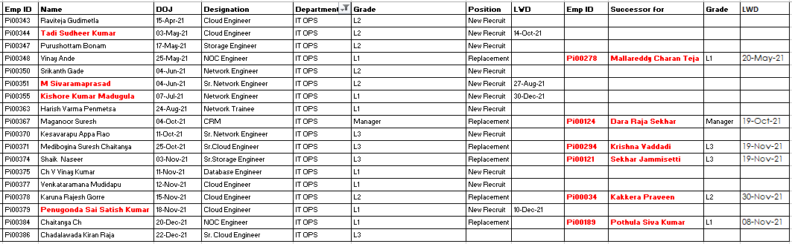

**4.2.1.1.1 Count of IT_OPS Employees from April 2020 to November 2021**

|  |  |
| --- | --- |
| Total (April) | 18 (Employee Id count) |
| Left (-) | 4 (New Recruit LWD) |
| Total (April) | 14 |

**4.2.2 PEOPLE ANALYTICS METRICS TO IT_OPS OF TALENT ACQUISITON DATA:**

Let’s consider two employees out of 18 with one context is explained.

Excel formula for Days Difference is: **DAYS(End_Date, Start_Date)** for all metrics

**Time to Fill:** The time between approving a job requisition and the candidate accepting your offer is often used to calculate the number of calendar days it takes to recruit and hire a new employee.

**4.2.2.1 Time to Fill**

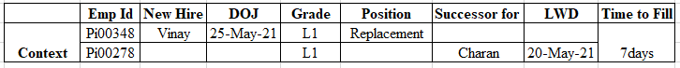

Context: Here the New Hire DOJ is five days prior to the Successor LWD that means this the time taken to fill this position is less.

**Calculation:**

**Formula: (Offer Acceptance Date - Position Vacancy Date) = Time to Fill.**

* Offer Accepted Date: 9thApril,2021. (after accepting offer from this organization, he served 30days notice period for the previous organization).
* Position Vacancy Date: 30thMarch,2021. (Successor-Charan has started his notice period from 5thApril,2021)
* The Successor Charan has informed manager about resignation on 25thMarch,2021.

**Time to Hire:** the interval between a job candidate's initial contact with a company and their acceptance of an offer of employment.

Consider the day you opened a certain position as Day 1 in order to determine the time to hire. Your time to hire would be 25-10 = 15 if your top prospect accepted your job offer on Day 25 and submitted an application on Day 10.

**Calculation:**

**Formula: (Offer Date - Application Received Date) = Time to Hire.**

* Specific position day is 5thApril,2021 and Offer accepted day is 9thApril,2021.
* Job application Received on 6thApril,2021.
* Application of formula: (5thApril,2021 - 9thApril,2021) that is 3days.

**Source of Hire:** Source of hire (SoH) displays the proportion of hiring that came from each recruitment source or channel (e.g. job boards, referrals, direct sourcing).

Source of Hire = Total Hires from a Source / Total Candidates from a Source = Percentage of Hires from a Source.

**Calculation:**

**Formula: (Total number of candidates from particular portal Number of Hires/) = Source of Hire**

* Application of Formula: (2/ 18) = 11.11Percentage from LinkedIn
* (16/ 18) = 88.88Percentage from Naukri.

**Previous Attrition:** the departure of staff from the business for whatever reason (voluntarily or not), such as through retirement, death, or termination.

Previous attrition = Number of Attritions/Average Number of Employees *100.

The Below is the Attrition Rate for entire organization:

**4.2.2.2 Overall Attrition from April 2020 to March 2021.**

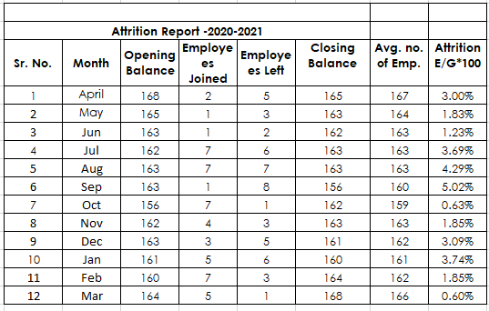

**4.2.2.3 Employee Turnover**

|  |  |
| --- | --- |
| Average Monthly Employment | 163 |
| Separations | 50 |
| Employee Turnover | 30.77% |

**Quality of Hire:** the value a new employee brings to your business. Specifically, how much a new hire adds to the long-term success of your business. It is clear from its definition why hiring for quality is given such importance.

**Calculation:**

**Formula: (Number of hired candidates satisfied/ Total number of Hires) = Success Ratio.**

* (12/18) = 66.66Percentage is the success ratio.
* Number satisfied candidates are derived by total hires – number of lefts.

**Applicants per Hire:**the proportion of those hired for a post who applied vs those who were hired.

**Calculation:**

**Formula:** **Applicants per Hire = divide the number of internal hires by the number of employees at the department.**

* (18/41) = 43.90Percentage is the Applicants per Hire.
* 43.90Percentage Applications are received for the job opening in the IT_OPS Department.

**Selection Ratio:**  The proportion of open positions to job applicants, which is utilised in the context of hiring and selection.

**Calculation:**

**Formula:** **Selection ratio = Number of Hires / Number of Applicants.**

* Number of applicants = total number of employees at department is 41. Where, Applicants per hire is 44Percentage approx. So, 44Percentage of 41 is 16 applicants approx.
* Application of Formula: (2/16) = 12.5Percentage is the selection ratio.
* Number of hires is 2. Because in time to fill metrics Noc Engineer post is considered. With reference to 4.2.1.1 Noc Engineers hired are 2 in count.

**Percent of Opening Positions:** A position that is open: For each post that is open, employers receive hundreds or even thousands of applications. also see posture long. position short.

**Calculation:**

**Formula:** **Percent of opening positions = (Number of Job Positions Filled / Number of Total Employees) *100**

* As per table 4.2.1.1 18 positions are filled and as per table 4.2.1 total employees are 41.
* Application of Formula: (18/41) *100 = 43.9%.
* That is 43.9% percentage of opening positions are there in IT_OPS Department in the assumed year.

The above are the few explained metrics in People Analytics with respect to Talent Acquisition as such there are various number of metrics to evaluate the various Human Resource Functions and attain better results.

**Interpretation:**

From the above Mathematical calculations with IT_OPS department data with respect to Talent Acquisition. For the considered context it is observed that:

**4.2.2.4 Interpretatio**n

|  |  |  |
| --- | --- | --- |
| **Interpretation for IT_OPS Department single position (Context)** | | |
| Metrics | Result | Comment |
| Time to Fill | 7 Days | For this position(context) it is good. But while observing 4.2.1.1 there are few closures which got delay than expected. |
| Time to Hire | 3 Days | Good Sign showcases employer need and employee interest. |
| **Interpretation for IT_OPS Department from April 2020 to March 2021** | | |
| Source of Hire | Naukri | 89Percentage Naukri is preferred as it has user friendly interface. |
| Previous Attrition | 30.77Percentage | Bad Indicator. Need lot of affords to implement best practices and address employee concerns. |
| Quality of Hire | 66.66Percentage | Moderate. Hiring is cost incurring issue to the organization which is one of the focal points. |
| Applicants per Hire | 43.90Percentage | Average. Organization need to focus more on people who are willing to work and do job postings in that circle. Like for more experienced candidate head hunt, below to that LinkedIn as such. |
| Selection Ratio | 12.5Percentage | Scrutiny process for the candidate is more important. |
| Percentage of opening positions | 43.9Percentage | It shows that separation is more which lead to opening. So, implementing employee retaining practices are more crucial with this organization. |

Over observation imputes that this organization is facing huge attrition rate which can be controlled/ reduced to some extent can be done through the talent acquisition function itself.

In the first case, it is demonstrated that there is a considerable correlation between employee churn and talent acquisition.

From the second scenario it is clear that application of people analytics to the talent acquisition will lead to evaluation of existing talent acquisition process and make modification as per the result which showcase the path to improve existing process.

In this analysis only Talent Acquisition function is considered. As, such application of people analytics to various functions in the organization with respect to reducing attrition will fetch the result which is an improvement to existing one and reduce/control the attrition.

So, **“THE STUDY OF RELATIONSHIP BETWEEN TALENT ACQUISITION AND EMPLOYEE ATTRITION USING PEOPLE ANALYTICS WITH REFERENCE TO PI DATACENTERS, HYDERABAD”** has proven that implementation of people analytics in Talent Acquisition will be able to control/reduce employee attrition to some extent by providing the way in terms of suggesting modifications in existing process, best decisions can be taken.

1. **SUMMARY**

Employee Attrition implies the percentage of employees leaving the organization. Lack of retention capability or misinterpretation of the data lead to the cause attrition.

Talent Acquisition reflects the proper management of demand and supply for the organization in terms of manpower.

In this study the opinions of employees are collected by underlying factors like

* What makes them give a thought for leaving the organization?
* What are the challenges they face while managing the potential manpower?
* Will application of people analytics metrics to talent acquisition fetch to better magnification of existing practices?

On such aspects the data is collected. Correlation is carried out to determination the relationship between Talent Acquisition and Employee Attrition. The result imputes the positive strong correlation. When there is a significant relationship between Talent Acquisition and Employee Attrition further the metrics of people analytics (with respect to talent acquisition) is been applied on IT_OPS department data at PI data centers. Where, the result indicated that there are few modifications required in the existing talent acquisition practices which are inculcated at PI data centers.

**5.1 FINDINGS**

This study was conducted in Pi Data Centers Pvt. Ltd at Amaravati office on the relationship between talent acquisition with employee attrition using People analytics metrics. The primary objective of this is to find out whether there is a significant relation between talent acquisition and employee attrition or not. The key findings indicated that talent acquisition positively and significantly correlate and influence the employee attrition in terms of controlling or reducing it.

The secondary objective of this is to find whether the application of People analytics to talent acquisition will help to reduce and control the employee attrition as there is significant relation between the talent acquisition and employee attrition. The key findings indicated that application of People analytics to talent acquisition process followed in pi data centers at present can be made better by making small modifications.

* + 1. **Regarding Respondents Profile**
* Majority employees of pi data centers is in productive age. Minimal percentage of pi data centers employees that is 7Percentage are nearer to retirement age in the upcoming future.
* Female dominancy can be viewed in workforce of pi data centers is been observed.
* Majority employees of pi data centers are in the category of under graduation respectively.
* Experienced workforces who represent majority had been working in the organization for 3-5 years.
* Majority of workforce were representing that they are getting 36,000 INR to 50,000 INR
* More than half count of employees in pi data centers are married.
  + 1. **Regarding Employee Attrition**
* In recognition of importance of controlling the employee attrition rate which is cost and time-consuming concerns to the organization. The organizations need to control and reduce the attrition by which they can save their resources.
* Working environment will help the employee to generate the opinion about the organisation and majority of respondents Agree that Organization  
  Working Environment in pi data centers testify by choosing strongly disagree to strongly agree.
* Majority of respondents were agreed and strongly agreed on the aspect of revising the leave policy. Leave policy is one of the policies in the organization that motivate the employees as well as it helps the organization to imputes its concern towards employees.
* More count of respondents has strongly agreed on pi data centers encourage them to share knowledge with the co-workers. As, Knowledge sharing is one the  
  key aspect which helps them to keep connected, perform better and become better in the aspect of being professional.
* Because team work will encourage personal growth, helps in attaining job satisfaction and reduce the work stress. Majority of respondents agreed and strongly agreed that pi data centers employees believe in team work.
* Majority of respondents has strongly agreed as the employees in pi data centers they actively engage in networking at work place.
  + 1. **Regarding Talent Acquisition**
* Talent Acquisition is another important concern to the organization in terms of various aspects like:
* Placing right candidate at right place in the right time.
* Maintaining the buffer to fulfil sudden requirements.
* Keeping track of candidate.
* Fulfilling the contract to hire on basis of client requirement as such.
* Majority respondents has strongly agreed that mentioning the green flags in term of key performance indicators in the candidate will be assed priory before developing job analysis document for a position.
* Majority of respondents have strongly agreed that cost and time are most difficult requirements to fulfil the position required.
* Because of lack of practical exposure few candidates are rejected due to the level position required to be filled.
* Respondents strongly agreed that notice period to be served is one of the causes for rejection of candidate in terms of job requirement.
* Negotiations about compensations result-in rejection of offer letter which is strongly agreed by more respondents.
* More respondents strongly agreed that lack of career growth opportunities in the firm lead to the rejection of offer even in the after qualifying all the round sin the interview process.
* In HR round if the explained task environment doesn’t match the job profile majority says that they tend to reject the offer.
* Because of lengthy interview process or delay in responding to the candidates lead to offer rejection which is strongly agreed by maximum respondents.
* Majority of respondents strongly agreed that in-bucket process will help to get good candidates which result-in high hit ratio in terms of closing a position.
* Maximum respondents have strongly agreed that time and cost are the major resources which can help the firm to frame an optimum sourcing plan from various online job portals.
* Time and Cost are considered as major bottlenecks in the talent acquisition process by majority of respondents.
* Selecting a candidate who meet the requirement for the technical positions is hurdle for the HR department which is strongly agreed by most of the respondents.
* In few cases even though the candidate accepts the offer letter they won’t report to the office as per the joining letter. So, the offer acceptance and joining letter reporting are also the bottlenecks in the talent acquisition process which is strongly agree by maximum respondents.
  + 1. **Regarding Application of People Analytics to Talent Acquisition**
* In this study the People Analytics is applied only to IT_OPS Department which consists of 41 employees from April 2020 to March 2021.
* There are many People analytics metrics to evaluate the talent acquisition process and make modification to make it more effective. But in this study six metrics are implemented due to data limitations.
* The six metrics are:
  + Source of Hire.
  + Previous Attrition.
  + Quality of Hire.
  + Applicants per Hire.
  + Selection Ratio.
  + Percentage of Opening Positions.
* Source of Hire imputes that Naukri is mostly used by pi data centers in order to meet the closure requirements for the positions.
* Previous Attrition data is collected from pi data manager which showcase that Pi data center is facing huge attrition rate which is around 30.77Percentage for entire organization which is a bad number.
* Quality of Hire is about the number of position result-in hit ratio which is 66.66Percentage that is moderate in nature.
* Number of applications received for a position is applicants per hire that is 43.90Percentage which require more spread of word about the position vacancy.
* Selection Ratio is 12.5Percentage which showcase the percentage of candidate got hired from total applicants for apposition.
* 43.9Percentage of position are opening in that particular year at pi data centers IT_OPS Department which indicate there is a need of more retention practices.
  1. **RECOMMENDATIONS**

It is undeniable fact that in recent times many organizations have facing huge attrition rate due to drastic change in work patterns because of pandemic situation.

To increase the retention rate, build the best practices in organization to keep them engaged at work place and enjoy. They can be like:

* Conduct Engaging team-building activities which boost their energy.
* Take time to celebrate Champions where performance cannot take place by chance it’s the result of continuous affords from the employee.
* Make Fridays fun to create a good relation among employee-to-employee and employer-to-employer.
* At equal intervals make time and interact with the team to know their concerns.
* Keep your organization stand align with the competitor organizations pay for the various levels of positions.
* Implement Social Everyone platform to promote free flow of communication between different departments result-in good networking at workplace.
* Conduct Award ceremony based on performance evaluation of employee results with the view of celebrating the hard work of our team.
* The majority are women respondents it is good to have women leadership programs.

Hiring the right candidate at right place in right time is also a huge challenge as the pandemic has changed the view of employee towards the job.

* + A - Attitude toward the work, employer, colleagues is changed.
  + B - Behavioural changes towards the context.
  + C - Communication became online.
  + D - Dream (How the job is to be some time it is unrealistic).

The Re-skilling pattern of old times is changed to three W’s like:

* + Work (virtual mode mostly preferred by employees).
  + Work Place (No wear from Office. if it is hybrid work model have come into picture).
  + Workforce (Competencies required are changed – Along with professional or work-oriented skills digital skills are also needed now).

Implementation of Recruiting Yield Pyramid will help to assess the talent acquisition process from roots and make it more effective.

Let’s consider there a need for the organization to hire 10 members. On an average as attrition rate is so high in pi data centers. Consider there is a need to have 240 leads at least.

In the below pyramid the new hires are 22 as the position to be filled are 10 extra 12 are kept in buffer.

Hit Ratio is 24:1 (where 24 is leads generated for one position)

However, not only quantity of leads matter. Nut, quality of leads also matters to ensure closures (new hires).

As, involving new concepts in the talent acquisition process will fetch the scope for better decision making and effectiveness in process followed.

New Hires

22

60

Offers Made

Candidates Interviewed

212

110

Invited

Leads Generated

240

**5.3.1 Recruiting Funnel**

To make better evaluation of talent acquisition process using People analytics. The depth concepts in People analytics can be applied to talent acquisition data obtained.

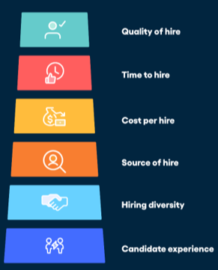Source: Vervoe

* + 1. **People Analytics Effective Funnel for Talent Acquisition**
  1. **CONCLUSION**

Talent Acquisition and Employee Attrition are very crucial to an organization and its effectiveness. In the lights of the above, the organizations are therefore encouraged to implement new technologies in their existing process and make the necessary modifications to get better results by improving its effectiveness and efficiency. Employees are the organization great assets which made organizations mandated to retain the potential employees by letting them know that organization values them as an individual and affords towards the organization. The Human Resource Department is crucial in developing the best talent acquisition strategy and in lowering or controlling the attrition rate.

The following are the conclusions were obtained from the findings:

The Pi data centers is facing huge attrition rate from April 2020 to March 2021which can be clearly viewed in the table 4.2.2.2. It is imputed for entire organization of Amaravati location.

The Talent Acquisition of pi data centers is positively and strongly correlated (r = 0.634, p < 0.001) with Employee Attrition. As results the evaluation and improvement in Talent Acquisition Process in pi data center will control the attrition to some extent.

Pi data centers usually has two type of talent acquisition process one is for internal purpose to fill the pi data centers company position and the other is for external purpose which is contract-to-hire. Interpretations in 4.2.2.4 showcase that Talent Acquisition process practiced at present by pi data is not much efficient. Practices inculcated in pi should be more effective than present to meet client demands and internal requirement.

The considered hypothesis is tested - There is a significant relation between talent acquisition and employee attrition in the first scenario.

From the application of people analytics to the talent acquisition the result lead to evaluation of existing talent acquisition process and make modification as per the result which showcase the path to improve existing process. The Talent Acquisition is one of the many functions lead to attrition in view of Human Resource.

The Talent Acquisition process of pi data centers is not good enough to make its contribution to Employee Attrition in terms of controlling or reducing it.

* 1. **BIBLIOGRAPHY**

1. The Basic principles of people Analytics.

Source:<https://www.aihr.com/resources/The_Basic_principles_of_People_Analytics.pdf>

1. Introduction to People Analytics.

Source: <https://www.perlego.com/book/1589606/introduction-to-people-analytics-a-practical-guide-to-datadriven-hr-pdf>

* Richa Chetan Charwad1, Smita Chaitanya Pangarkar2. (2022) - A Study on The Great Resignation of TCS. Vol-8 Issue-2 2022.
* M. Bhuvaneswari1 Dr. R. Kavitha2. (2022) Attrition issues of employees in pharmaceutical industries. 2022 JETIR February 2022, Volume 9, Issue 2.
* Shobhanam Krishna and Sumati Sidharth (2022) - HR Analytics: Employee Attrition Analysis using Random Forest Vol.18 Issue (4)
* Ragimol, Dr. A. G. Sudha, Dr. F. J. Peterkumar (2021) Effective wworkforce management using HR Analytics Volume 03 Issue 06S
* H.H.D. Pooja Jayani Opatha (2020) – HR Analytics A literature review and new conceptual model DOI:10.29322/IJSRP.10.06.2020.p10217
* Hussain Aqeel, K.R. Chaturvedi (2020) - Retention Strategies for Front Line Sales Employees A Study of Insurance Sector in India
* Biminis Rajasekharan, A STUDY ON MEASURING THE TALENT ACQUISITION PRACTICES IN SELECTED IT COMPANIES IN CHENNAI, TAMILNADU - June 2021
* Garima Kohli, Research Paper on "Talent Acquisition Latest Trends" , Volume : 3 | Issue : 4 | May 2013.
* Priyanka John Attupuram, Talent Acquisition Process in a Multinational Company: A Case Study, January 2015, SSRN Electronic Journal DOI:10.2139/ssrn.2708086.
* Priyanka John, Attupuram, A.H. Sequeira, Sivakumar Gopalakrishnan Talent Acquisition Process in a Multinational Company: A Case Study DOI:10.2139/ssrn.2708086
* Bhattacharyya, D.K. (2017), HR Analytics: Understanding Theories and Applications. New Delhi: SAGE Publications.
* 3Chib, S. (2019), “Monograph on HR reporting using using HR dashboards”, International Journal of Scientific and Research Publications.
* Fred, M.O. and Kinange U.M. (2015), “Overview of HR Analytics to maximize Human capital investment”.
* Gurusinghe, N, Arachchige, B.J.H. and Dayarathna, D. (2019), Identified Research Gaps in HR Analytics, Conference: Challenges to
* Humankind in the Face of New Technologies at Colombo, Sri Lanka. Jabir, B., Falih, N. and Rahmani, K. (2019), “HR analytics a roadmap for decision making: case study”.
* Indonesian Journal of Electrical Engineering and Computer Science, Vol. 15, No. 2, pp. 979-990. Jain, A. and Nagar, N. (2015), “An Emerging Trend in Human Resource Management”, SS International Journal of Economics and Management, Vol. 5, No. 1, pp. 1-10.
* Kiran K.S., Sharma, N. and Brijmohan D.R. (2018), “HR analytics: transactional to transformational HR approach”, International Journal of Advance and Innovative Research, Vol. 5, No. 3, pp. 1-11.
* Kirtane, A. (2015), “corporate sustainable HR Analytical practices”, Journal of Management & Administration Tomorrow, Vol. 4, No. 1, pp. 33-40.
* Levenson, A.R (2005), “Harnessing the power of HR analytics: why building HR’s analytics capability can help it add bottom-line value”, Center for Effective Organizations, Vol. 4, No. 3, pp. 3-12.
* Lochab, A., Kumar, S. and Tomar, H. (2018), “Impact of Human Resource Analytics on Organizational Performance: A Review of
* Literature Using R-Software”, International Journal of Management, Technology And Engineering, Vol. 8, pp. 1252-1261.
* Malla, J. (2018), “HR Analytics Center of Excellence”, International Journal of Business, Management and Allied Sciences, Vol. 5, 282-284.
* Mohammed, A.Q. (2019), “HR analytics: a modern tool in HR for predictive decision making”, Journal of Management, Vol. 6, No. 3, pp. 51-63.
* Momin, W.Y.M. and Mishra, K. (2016), “HR analytics: Re-inventing human resource management”, International Journal of Applied Research, Vol. 2, No. 5, pp. 785-790.
* Opatha, H.H.D.N.P. (2009), Human Resource Management: personnel. Sri Lanka: University of Sri Jayewardenepura.
* Opatha, H.H.D.N.P. (2019), Sustainable Human Resource Management. Sri Lanka: University of Sri Jayewardenepura.
* Opatha, H.H.D.P.J. and Uresha, K.I. (2020). HRM and its impact on employee happiness: An empirical study on Sri Lankan employees,
* Asian Journal of Social Sciences and Management Studies, Vol. 7, No. 2, pp. 114-123.
* Reddy, P.R. and Lakshmikeerthi, P. (2017), “‘HR Analytics’ - An Effective Evidence Based HRM Tool”, International Journal of Business and Management Invention, Vol. 6, No. 7, pp. 23-34.
* Reena, R, Ansari, M.M.K. and Jayakrishnan, S.S. (2019), “Emerging trends in human resource analytics in upcoming decade”,
* International Journal of Engineering Applied Sciences and Technology, Vol. 4, No. 8, pp. 260-264.
* Singh, P., Upadhyay, R.K. & Srivastava, M. (2017), “The role of HR analytics in higher education institution”, International Journal of Engineering Sciences & Research Technology, Vol. 6, No. 7, pp. 92-100.
* Bauer, T., Truxillo, D., Paronto, M., Weekley, J. and Campion, M. (2004), Applicant reactions to different selection technology, International Journal of Selection Assessment, Vol. 12, Nos. 1/2, March / June.
* Barclay, J.M. (2001), Improving selection interviews with structure: Organizations’ use of “behavioral” interviews, Personnel Review, Vol. 30, No.1, pp. 81-101 55
* Barber, A.E. (1998), Recruiting employees: Individual and organizational perspectives, Sage Publications.
* Bernardin, John H. (2003); Human Resource Management: An experiential approach; McGraw Hill
* Blackman, M.C. (2002), Personality judgment and the utility of the unstructured employment interview, Basic and applied social psychology, Vol. 24, No 3, pp. 24 250
* Cappelli, P. (2001), Making the most of on-line recruiting, Harvard Business Review, Vol. 79 (3), March, pp. 139-146
* Cooper, D.R. and Schindler, D.A. (2010), Business Research Methods, 9th ed., London, MGraw-Hill.
* Cascio, W. (1998), Applied Psychology in Human Resource Management. New York: Prentice Hall, 5th Ed.
* Dineen, B., Noe, R. and Wang, C. (2004); Perceived fairness of web based applicant screening procedures: weighing the rules of justice and the role of individual differences; Human Resource Management, Summer/Fall, Vol. 43, Nos. 2 & 3, pp. 127–145. 10. Foot, M. and Hook, C. (2005), Introducing Human Resource Management, 4th Ed., Prentice Hall, Pearson Education.
* Gatewood, R.D., Gowan, M.A. and Lautenschlager, G.J. (1993), Corporate image, Recruitment image, and initial job choice decisions, Academy of ManagementJournal, Vol. 36, No 2, pp. 414-427
* Marchington, M. and Wilkinson, A. (2002), People Management and Development: Human Resource Management at Work, Chartered Institute of Personnel and Development, 2nd Ed.
* Robertson, I.T. and Smith, M (2001), Personnel Selection, Journal of occupational and organizational psychology, 74, pp. 441-472
* Bills D.B., Di Stasio V. & Gërxhani K. (2017). The demand side of hiring: Employers in the labor market. Annual Review of Sociology, 43, 291-310.
* Bonet R. & Hamori M. (2017). Talent intermediaries in talent acquisition. The Oxford Handbook of Talent Management, 249.
* Braojos-Gomez J., Benitez-Amado J., & Llorens-Montes F.J. (2015). How do small firms learn to develop a social media competence? International Journal of Information Management, 35(4), 443-458.
* Burks S.V., Cowgill B., Hoffman M., & Housman M. (2015). The value of hiring through employee referrals. The Quarterly Journal of Economics, 130(2), 805-839.
* Cai, Z. Huang, Q. Liu H. & Wang X. (2018). Improving the agility of employees through enterprise social media: The mediating role of psychological conditions. International Journal of Information Management, 38(1), 52-63.
* Davenport T. H. & Ronanki R. (2018). Artificial intelligence for the real world. Harvard business review, 96(1), 108-116.
* Dirican, C. (2015). The impacts of robotics, artificial intelligence on business and economics. Procedia-Social and Behavioral Sciences, 195, 564-573.
* Fenech R., Baguant P. & Ivanov D. (2019). The Changing Role of Human Resource Management in an Era of Digital Transformation. International Journal of Entrepreneurship, 22(2).
* Haahr L. & Holm A. B. (2018). Chatbots in Human Resource Management. In Robo-Philosophy 2018.
* Hoffman M., Kahn L. B., & Li D. (2017). Discretion in hiring. The Quarterly Journal of Economics, 133(2), 765-800

**ANNEXURE**

Questionnaire.docx

Demographics:

Age, Gender, Qualification, Experience, Income, Martial Status.

1 to 14 statements represent the Dependent Variable: Employee Attrition.

15 to 28 statements represent the Independent Variable: Talent Acquisition.

1. Organization Working Environment is Good?
2. The Company need to Revise its Leave Policy?
3. The Company Encourages Knowledge Sharing among Employees?
4. My Colleagues believe in Team Work?
5. I Actively Engage in Networking at Workplace?
6. My supervisor provides the actionable suggestions on what level an employee can do  
   to improve?
7. I take initiative in helping my colleagues?
8. I am satisfied with the current working conditions?
9. My ideas are well taken by my supervisor?
10. The company management understands its employees?
11. I prefer to work from home?
12. My company provides opportunities for career growth of its employees?
13. My company provides training opportunities to its employees?
14. Company provides fair salary for the work performed by you?
15. Cost and Time are the most difficult requirements to fulfil a position?
16. The "Green Flags" for a given job requirement is required to be assed? [Green Flags  
    are like Domain Knowledge, Practical Exposure, Certifications]?
17. Lack of Experience or Practical Exposure is of the root cause for rejecting candidates  
    for a job requirement?
18. Notice Period is root cause for rejecting candidates for a job requirement?
19. Candidates tend to reject offer due to Compensation?
20. The Candidates MAY reject offer when there is Lack of Career Growth  
    Opportunities in the Organization?
21. Job profile doesn't match the Task Environment lead to rejection of offer by the  
    candidate?
22. Lengthy Interview process lead to loss interest on the job which cause rejection of  
    offer by the candidate?
23. In-Bucket Provide "good candidates" that is high quality candidates in large number  
    with high hit rate?
24. The optimal aspects while framing sourcing plan through various channels are Time  
    and Cost?
25. Time and Cost are the Bottlenecks in Talent Acquisition process?
26. Sourcing and Short-Listing are the Bottlenecks in Talent Acquisition process?
27. Selecting is the Bottleneck in Talent Acquisition process?
28. Offer Accepting and Joining are the Bottlenecks in Talent Acquisition process?

**LIST OF ABBREVIATIONS**

|  |
| --- |
| **Abbreviation** |
| EA - Employee Attritions |
| TA - Talent Acquisition |
| IT_OPS - Information Technology Operations |
| HR - Human Resource |
| DOJ - Date of Joining |
| LWD - Last Working Day |
| EMP ID - Employee Identity |
| INR - Indian Rupee |

**PLAGIARISM CERTIFICATE**

**ON**

**A STUDY ON RELATIONSHIP BETWEEN TALENT ACQUISITION AND EMPLOYEE ATTRITION USING PEOPLE ANALYTICS WITH REFERENCE TO PI DATACENTERS, HYDERABAD.**

